Applying Proportional Reasoning to Solve Problems
Understands the concept of rate  and unit rate  A rate is a comparison of two quantities with different units  (e.g., 3 kg cost $6, 100 km in 2 h).  Unit rate is the rate for one unit  (e.g., $2/kg, 50 km/h) | Understands that unit rate is proportional  The average speed of a cyclist is  25 km/h.  How far will the cyclist travel in 3 h?  Cyclist travels 25 km in 1 h.  So, in 3 h, cyclist travels:  3 × 25 km = 75 km | Solves a proportional problem involving percent  4 students in a class play hockey.  This is 20% of the class.  30% of the class play soccer.  How many students play soccer?  20% is 4 students.  So, 10% is 2 students.  And 30% is 3(2) = 6 students | Uses a variety of strategies to solve problems involving ratios, rates,  and percents  On a class trip, for every 3 students who skied, 2 snow-boarded.  64 students snow-boarded.  How many students skied?  Let s represent the number of students who skied.  Solve a proportion.  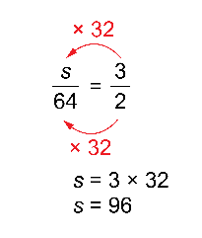  96 students skied.
Observations/Documentation

