Exploring Proportional and Non-Proportional Situations
Identifies a proportional situation in a table of values or a ratio table  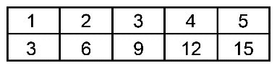  This is a proportional situation because the ratios are equal:  $\frac{1}{3}$= $\frac{2}{6}$= $\frac{3}{9}$= $\frac{4}{12}$= $\frac{5}{15}$ | Identifies a non-proportional situation in a table of values or a ratio table  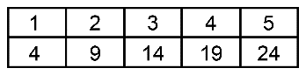  This is not a proportional situation because the ratios are not equal:  $\frac{1}{4}$≠ $\frac{2}{9}$≠ $\frac{3}{14}$≠ $\frac{4}{19}$≠ $\frac{5}{24}$ | Identifies whether a graph represents a proportional situation  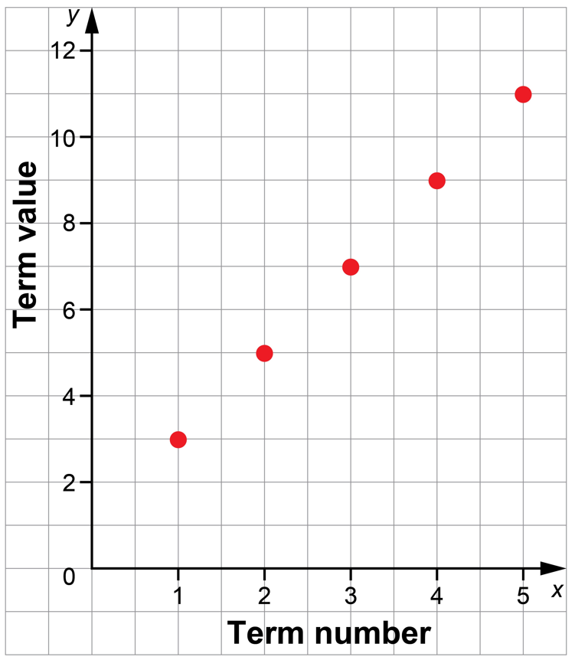  The coordinates do not have the same ratio and the line will not pass through the origin, so the graph does not represent a proportional situation. | Chooses a strategy to solve a proportion problem  In a design, the ratio of rectangles  to squares is 3 to 7.  There are 56 squares.  How many rectangles are there?  Make a ratio table and extend it  to 56 squares.  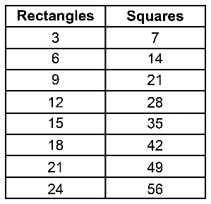  There are 24 rectangles.
Observations/Documentation

