Multiplying Decimals
Estimates the product of  two decimals  3.8 × 12.3  “3.8 is close to 4 and 12.3 is close  to 12. I can estimate the product as 4 × 12, which is 48.” | Multiplies a decimal by a whole number using a method of their choice  3 × 2.4  “I can think of this as 3 hops of 2.4 on a number line.  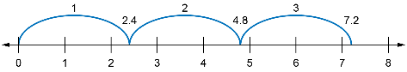  3 × 2.4= 7.2.” | Multiplies a decimal by a decimal using whole numbers  “To calculate 12.8 × 9.3, I can multiply each number in the product by 10. The calculation becomes  128 × 93, which I know how to do.  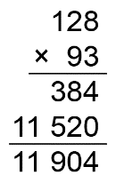  Since I multiplied the terms in the product by 10 × 10, or 100, I need  to divide my answer by 100.  12.8 x 9.3 = 119.04.” | Solves applied problems that involve the multiplication of decimals  Nola earns $28.74 per hour as an apprentice millwright. How much do they earn in 7.5 h?  “I know 8 × 30 = 240, so my answer should be less than $240.  I need to determine 28.74 × 7.5  I create a related product by multiplying the first number by 100 and the second number by 10.  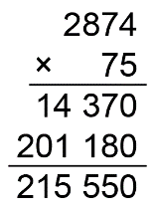  Since I multiplied by 100 × 10, or 1000, I divide the answer by 1000. Nola earns $215.55.”

Observations/Documentation

