Multiplying Fractions
Multiplies a fraction by a whole number  3 × $\frac{3}{4}$  “I can think of this as 3 hops of $\frac{3}{4}$  on a fraction number line.  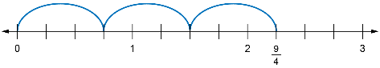  From the diagram, 3 × $\frac{3}{4}$= $\frac{9}{4}$.” | Multiplies a whole number by  a fraction  $\frac{3}{4}$× 3  “I want to find three-fourths of 3.  I can start by drawing 3, dividing it into 4 equal parts, then shading 3  of these parts.  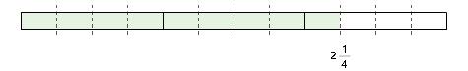  From the diagram, $\frac{3}{4}$× 3 = 2$\frac{1}{4}$, which  is the same as 3 × $\frac{3}{4}$.” | Multiplies a fraction by a fraction  $\frac{2}{3}$× $\frac{3}{4}$  “I drew a rectangle and shaded $\frac{1}{2}$  of it. Then drew a pattern of dots  on $\frac{3}{5}$ of the region I shaded.  In my diagram, there are 10 equal regions and 3 of them are shaded  and dotted. So, $\frac{3}{5}$× $\frac{1}{2}$= $\frac{3}{10}$.”  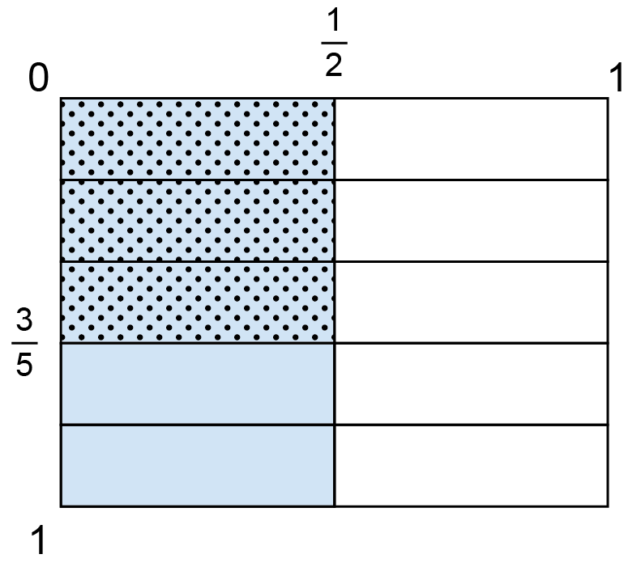 | Represents and solves problems that involve fraction multiplication  Luca has 3 identical pails of water.  Each pail is $\frac{3}{4}$full. If Luca combines  the water, how many pails can  be filled?  “I drew 3 rectangles to represent the pails. I divided each into 4 equal parts and shaded 3 parts of each pail. I thought about how I could combine them to form complete  pails. There were 2 full pails plus  $\frac{1}{4}$ extra. So, the answer is 2$\frac{1}{4}$ pails.”  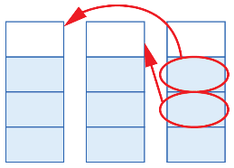
Observations/Documentation

