Subtracting Integers
Writes an expression to describe  a given model of integer subtraction  What difference could this model represent?  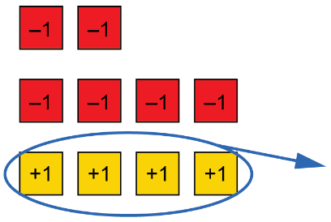  “The model represents (–2) – (+4) because you would need to add 4 zero pairs to –2 to be able to subtract 4. | Subtracts a positive integer with  or without a model  (–2) – (+3)  “I can use tiles to subtract 3 from –2. I start with 2 red tiles to represent –2. I want to take away 3 yellow tiles but don’t have any. So, I add 3 zero pairs and then remove the yellow tiles. I am left with 5 red tiles,  so the answer is –5.”  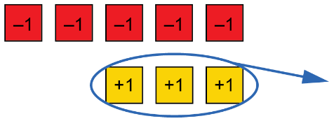 | Subtracts a negative integer with  or without a model  “I know that one meaning of difference is the distance between  2 numbers, starting from the number being subtracted. I can use a number line to determine 2 – (–4).  The difference is +6.”  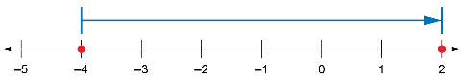 | Uses integers to model and solve applied problems  One winter evening it was –5ºC. Overnight, the temperature decreased by 7ºC.  Write a subtraction sentence, then calculate the difference to determine the temperature the next morning.  “The starting temperature was –5ºC. Since the temperature decreased by 7ºC, I can represent the situation as (–5) – 7, which is the same as  –5 + (–7), or –12.  The temperature the next morning was –12ºC.”
Observations/Documentation

