Adding Integers
Uses integers to represent real-life situations  Urs climbs 5 steps up a ladder then 3 steps down. How can you use integers to represent climbing a ladder?  “I can think of climbing 5 steps up as being a positive integer (+5) and climbing 3 steps down as being a negative integer (–3). Being on the ground would be 0.” | Writes an addition sentence for a given model  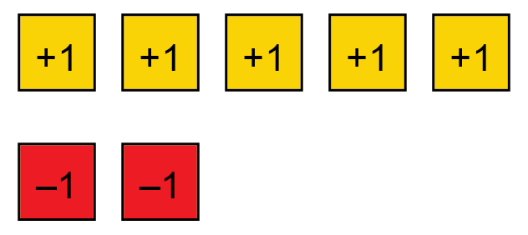  “Each yellow tile represents positive 1 and each red tile represents negative 1. I can remove 2 zero pairs and there are 3 yellow tiles left. The model represents the sum  5 + (–2) = 3.” | Adds integers with or without  a model  “I can use a number line to determine the sum 4 + (–6).  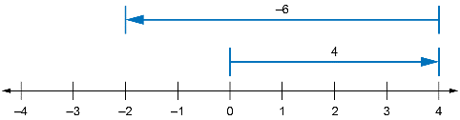  The sum is –2.” | Uses integers to model and solve applied problems  One winter morning it was –5ºC.  By the afternoon, the temperature had increased by 3ºC.  Write an addition sentence, then calculate the sum to determine the afternoon temperature.  “The morning temperature was  –5ºC. Since the temperature increased by 3ºC, I can represent the situation as (–5) + (+3), which is equal to –2.  The afternoon temperature was  –2ºC.”
Observations/Documentation

