Interpreting a Model
for Fraction Multiplication

Number
Unit 2 Line Master 9

It takes $\frac{4}{5}$of a can of paint for George to paint all the walls of a room.
George has painted $\frac{3}{4}$of the walls of the room.
1. What expression describes how much paint George has used so far?

2.How does this diagram represent George’s situation?
It may help if you add labels.

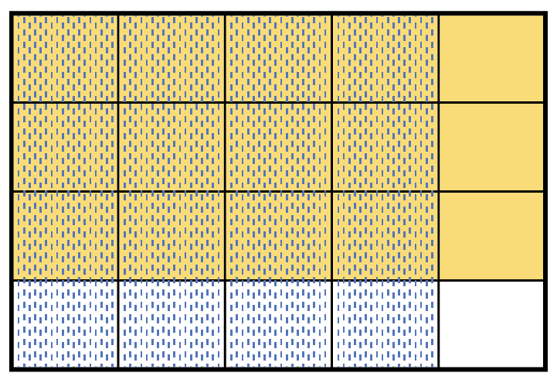

3. Use the diagram to determine how much paint George has used so far.

