Comparing Dog Food Prices

Number
Unit 2 Line Master 12a

Jhanel is comparing dog food prices.
Which bag has the better price?
Complete the questions to find out.
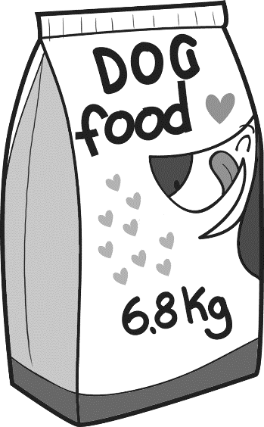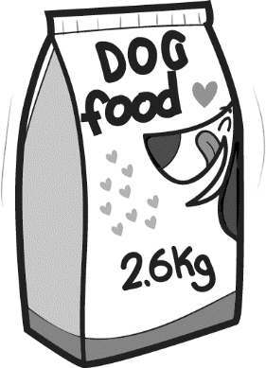
Green Leaf Dog Food
2.6 kg for $29.99
Blue Leaf Dog Food
6.8 kg for $69.99

Unit price is the price per unit.
It is calculated by dividing the price by the number of units.
Determining a unit price lets us compare prices of things
sold in different quantities.

1. For the dog food, the unit price is the price per kilogram.
Estimate the price per kilogram for each brand.
Explain how you made your estimates.

Comparing Dog Food Prices (cont’d)

Number
Unit 2 Line Master 12b

2. You pay $69.99 for 6.8 kg of Blue Leaf Dog Food.
So, the unit price is 69.99 ÷ 6.8.
To calculate the unit price, you can use a scaling process
like you used when multiplying decimals.
a) Write an equivalent division expression by multiplying
each number by 100.

b) Use the division algorithm and your equivalent division
expression from part a) to determine the unit price for Blue Leaf.

To check if your answer is reasonable, compare it to your estimate from Question 1.
)

Comparing Dog Food Prices (cont’d)

Number
Unit 2 Line Master 12c

3. You pay $29.99 for 2.6. kg of Green Leaf Dog Food.
a) Write a division expression for the unit price.

b) Write an equivalent division expression by multiplying
each number by 100.

c) Use the division algorithm and your equivalent division
expression from part b) to determine the unit price for Green Leaf.
To check if your answer is reasonable, compare it to your estimate from Question 1.

)

Comparing Dog Food Prices (cont’d)

Number
Unit 2 Line Master 12d

4. a) Which brand has the lower unit price?

b) What factors other than price might affect which bag
of dog food Jhanel buys?

