Number
Unit 2 Line Master 1
Using Models to Add Integers

1. State the sum shown by each model.
What do you notice?
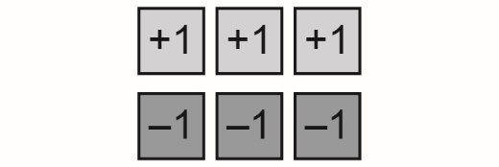
a)

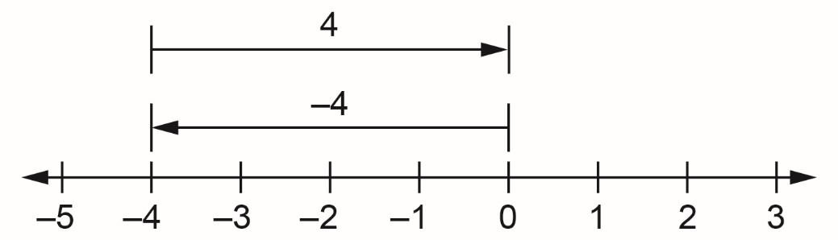
b)

2. Use a model of your choice to determine each sum.
What do you notice?
a) 5 + (–4)

b) (–5) + 4

c) (–5) + (–4)

