Investigating Perfect Squares and their Square Roots
Uses the area of a square to identify perfect squares  “25 is a perfect square because it can be represented by a square with area 25 units².  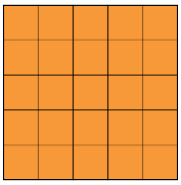  24 is not a perfect square because it can’t be represented by a square.” | Identifies a perfect square using the number of factors  “The factors of 16 are:  1, 2, 4, 8, 16  16 is a perfect square as it has an odd number of factors.  The factors of 17 are:  1, 17  17 is not a perfect square because it has an even number of factors.” | Identifies the square root of a number from a list of its factors and records using square root symbol  “The factors of 36 are:  1, 2, 3, 4, 6, 9, 12, 18, 36  $\sqrt{36}$ = 6, because 6 × 6 is the only pair of factors that are equal.” | Solves problems involving squares or square roots  A square field has perimeter 48 m.  What is the area of the field?  The side length is 12 m, so the area is 122 m² = 144 m².
Observations/Documentation

