Wole Numbers to One Billion around Us
Represents a number to millions in different ways  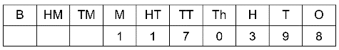  “one million one hundred seventy thousand three hundred  ninety-eight”  1 × 1 000 000 + 1 × 100 000 + 7 × 10 000 + 3 × 100 + 9 × 10 + 8  1 × 10⁶ + 1 × 10⁵ + 7 × 10⁴ + 3 × 10² + 9 × 10¹ + 8 | Represents a number to billions in different ways  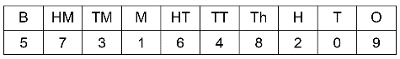  “five billion seven hundred thirty-one million six hundred forty-eight thousand two hundred nine”  5 × 1 000 000 000 + 7 × 100 000 000 + 3 × 10 000 000 + 1 × 1 000 000 + 6 × 100 000 + 4 × 10 000 +  8 × 1000 + 2 × 100 + 9  5 × 10⁹ + 7 × 10⁸ + 3 × 10⁷ + 1 × 10⁶ + 6 × 10⁵ + 4 × 10⁴ + 8 × 10³ + 2 × 10² + 9 | Compares and orders numbers to billions  Use a place-value chart to compare  985 327 902 and 1 238 902 716.  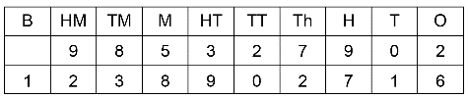  1 238 902 716 is greater. | Solves problems involving the comparison of large numbers  Suppose one metre represents  1 billion.  What measurement represents  1 million?  One billion is 1000 times as great  as 1 million.  In 1 m, there are 100 cm, and  1000 mm.  So, 1 mm represents 1 million.
Observations/Documentation

