Exploring Volume and Capacity Relationships
Understands that capacity is a measure of the amount a container can hold  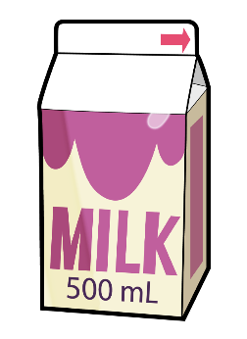  The capacity of the milk carton is 500 mL. | Understands that a container with  a capacity in millilitres has a volume that is the same number of cubic centimetres  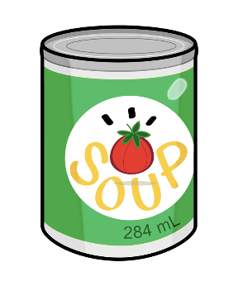  The capacity of the can is 284 mL.  The volume of the can of soup  is 284 cm³. | Relates 1 L to 1000 cm³  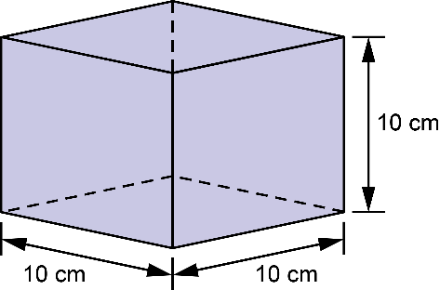  Volume of the cube:  10 cm × 10 cm × 10 cm = 1000 cm³  Capacity of the cube is 1000 mL = 1 L | Calculates the capacity of a container given its dimensions in centimetres  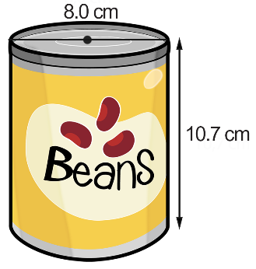  V = πr²h  V = π × 4² × 10.7  V $≈$ 538  Volume is about 538 cm³, so the capacity is about 538 mL.
Observations/Documentation

