Determining the Volume of Prisms and Cylinders
Understands that volume is a measure of the space filled by an object  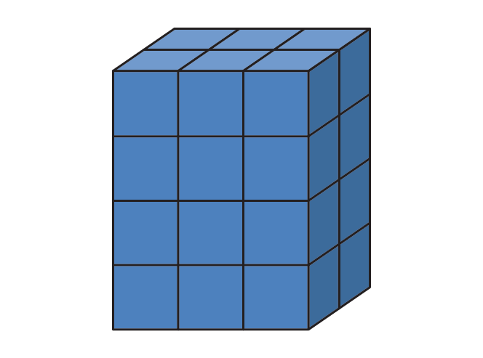  The volume of the prism is  24 unit cubes. | Understands that the volume of  a prism is the product of the area  of its base and its height  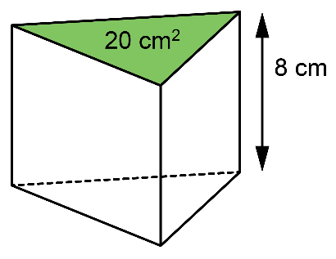  Volume of the triangular prism is:  20 × 8 = 160  The volume is 160 cm³. | Determines the volume of a cylinder  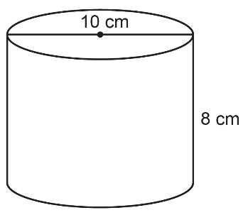  Base area of cylinder is: π × 5²  Height of cylinder is: 8  Volume of the cylinder is:  π × 5² × 8 = 628.318…  The volume is about 628 cm³. | Determines the area of the base, volume, or height of a rectangular prism or cylinder when given two of the three measurements  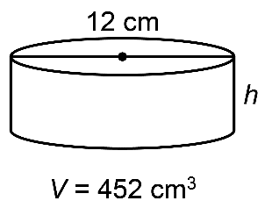  What is the approximate height of  the cylinder?  Volume:  V = πr²h  452 = π × 6² × h  452 = 113.09… × h  h ≈ 452 ÷ 113  h ≈ 4  The height is about 4 cm.
Observations/Documentation

