Determining the Surface Area of Cylinders
Recognizes the three different types of right cylinders  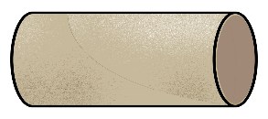  Cardboard tube: 2 open ends  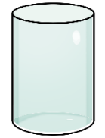  Cylindrical vase: 1 open end  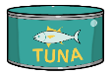  Can of tuna: 2 closed ends | Determines the surface area  of a cylinder with two open ends  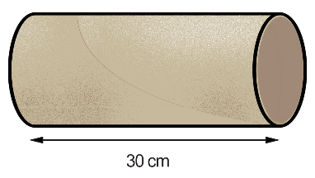  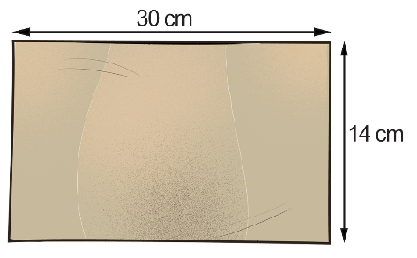  “I cut the cardboard tube at right angles to the circumference and flattened it to make a rectangle.  I measured its length and width.  Surface area = 30 cm × 14 cm  = 420 cm²” | Determines the surface area of cylinders with one/two closed ends  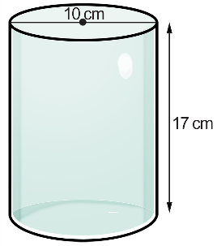  “The length of the curved surface is equal to the circumference of the circle, or πd.”  Surface area of vase:  (π × 10 × 17) + π × 5²  = 612.6…  The surface area is about 613 cm².”  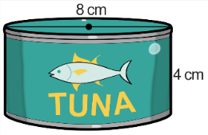  “Surface area of can:  (π × 8 × 4) + 2 × π × 4²  = 201.0…  The surface area is about 201 cm².” | Identifies the type of cylinder and applies the appropriate surface area formula for a given context  Bathroom tissue roll  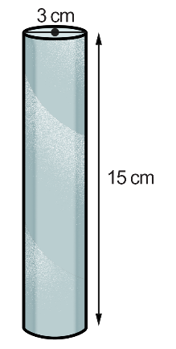  “This is an open cylinder. It has no bases.  Surface area:  SA = π × 3 × 15  ≈ 141.371…  The surface area is about 141 cm².”

Observations/Documentation

