Scale Drawings
Interprets blueprints and floorplans as top views of rooms  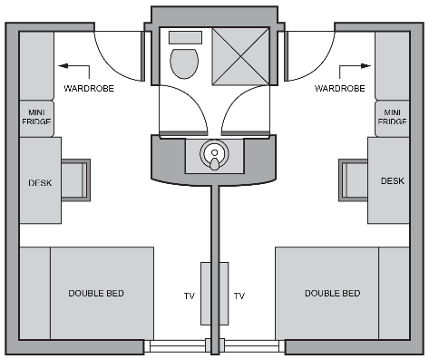  This is the plan for a dorm room.  I can see there are 2 beds, 2 desks, and a shared bathroom. | Draws a floor plan for a room, but does not apply an appropriate scale  I made a floorplan of my classroom at school.  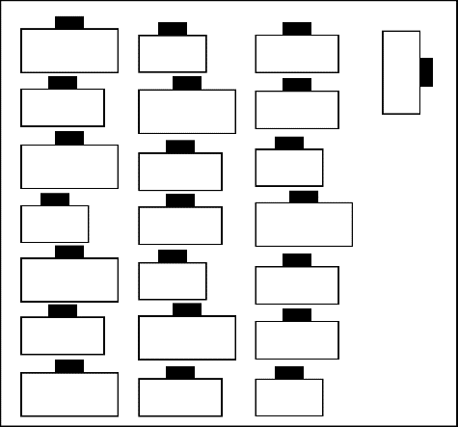 | Measures objects accurately and determines lengths needed on a diagram using an appropriate scale  I will use a scale of 2 cm represents 1 m. My desk is 1 m long, so I need to make it 2 cm long on my diagram. | Draws a floorplan using an appropriate scale  I made a floorplan for the computer room at our school. I used a scale  of 1 cm = 50 cm.  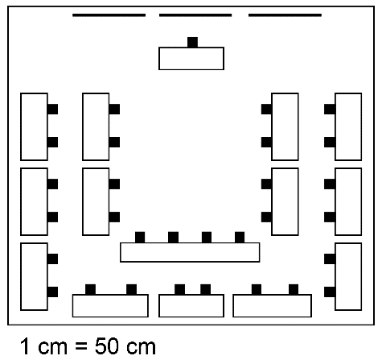
Observations/Documentation

