Drawing Views of 3-D Objects
Recognizes and draws the different views of a 3-D object  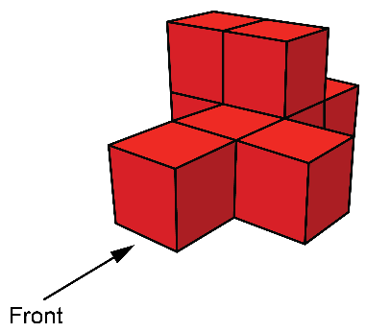  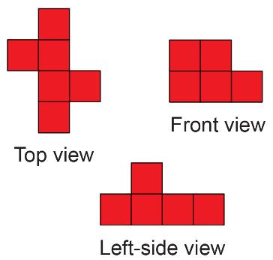 | Uses cubes to build structures with views that match given conditions  Build a cube structure that has  this as the front, left-side, and  right-side views.  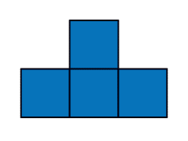  “I used 6 cubes to build this structure.”  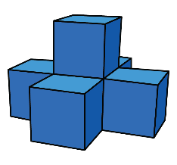 | Draws an isometric and a cabinet projection of a 3-D object  Isometric projection  Cabinet projection | Draws top, front, and side views  of real-world objects  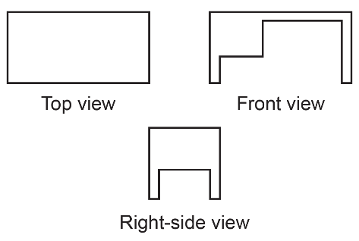  “I drew the top, front, and right-side view of the teacher’s desk.”
Observations/Documentation

