Symmetry in 3-D Objects
Understands the meaning of plane symmetry  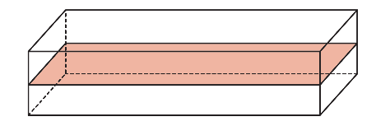  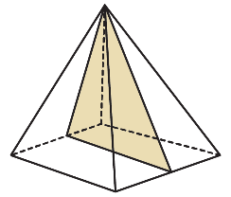  “A 3-D object has plane symmetry when it can be divided into two congruent parts that are mirror images of each other.” | Identifies the number of planes of symmetry for prisms, pyramids,  and cylinders  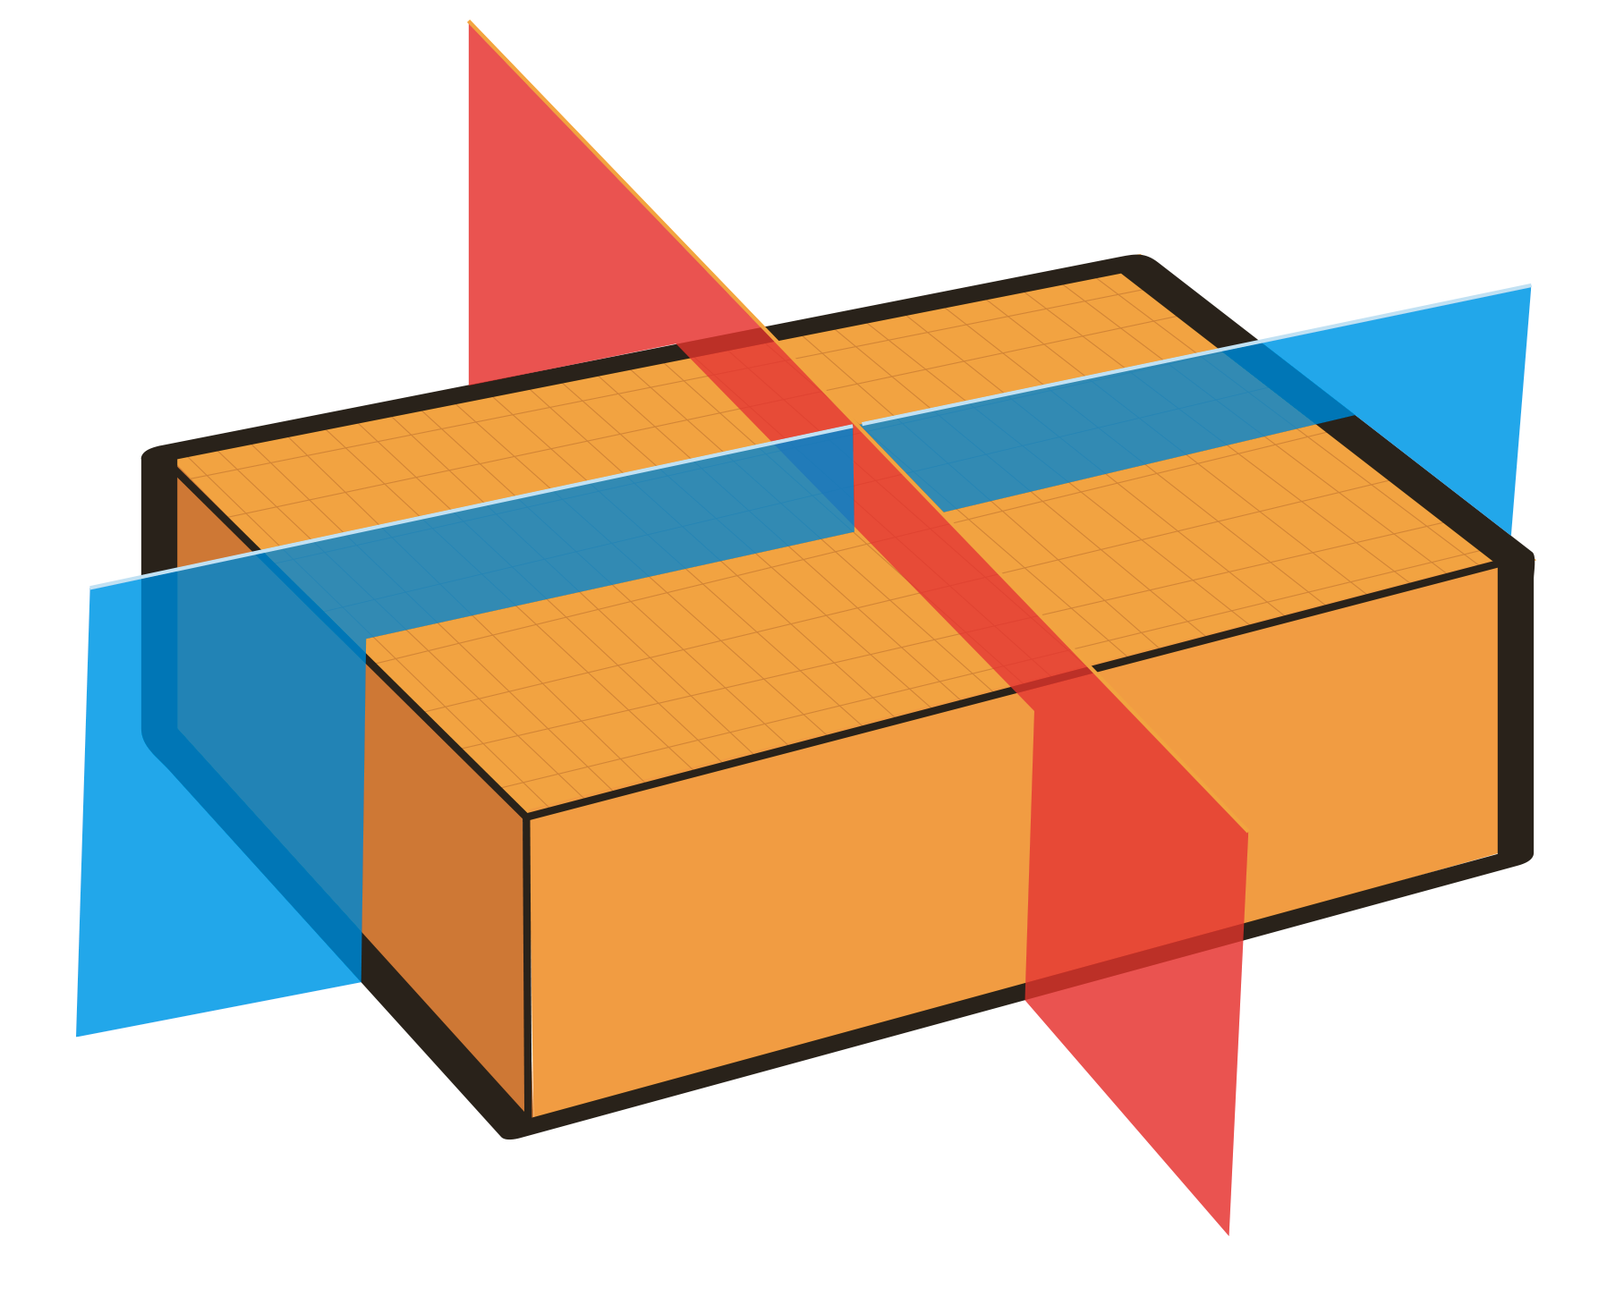  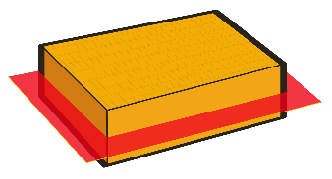  “A rectangular prism has 3 planes of symmetry.” | Understands and identifies the  order of rotational symmetry for  3-D objects  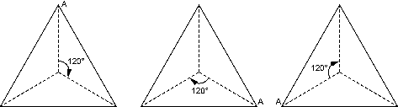  “A pyramid with a base that is an equilateral triangle has order of rotational symmetry of 3.” | Identifies 3-D objects with given numbers of planes of symmetry  and order of rotational symmetry  Which 3-D object has 7 planes of symmetry and order of rotational symmetry of 6?
Observations/Documentation

