Geometric Properties of 3-D Objects
Identifies prisms and pyramids  “This is a prism because opposite faces are parallel.  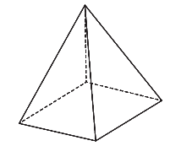  This is a pyramid because its triangular faces meet at a point.” | Identifies the properties of prisms and pyramids  “A rectangular prism has 6 faces, 8 vertices, and 12 edges.  A square pyramid has 5 faces,  4 of which are triangles, 8 edges, and 5 vertices.” | Identifies the properties of a cylinder  “A cylinder has 2 bases that are circles, no vertices, and a curved surface that joins the bases.” | Chooses two geometric properties and sorts 3-D objects in a Venn diagram  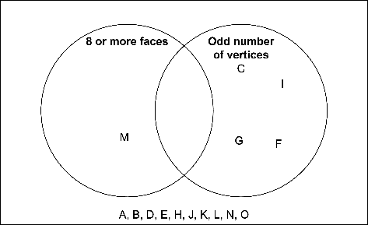  "The object in the left loop has 8 or more faces. The objects in the right loop have an odd number of vertices. The objects outside the loops have neither property.”
Observations/Documentation

