Dilating 2-D Shapes
Understands the concept of dilation  A dilation is a transformation that enlarges or reduces a shape by  a scale factor. The image is not congruent. | Describes the similarity between a dilated image and its original shape  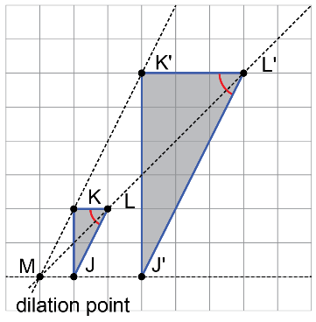  I used a protractor to find that corresponding angles, like ∠L and ∠L', are equal. I counted grid units of corresponding bases and heights to find the same ratio. For example,  $\frac{K'L'}{KL}$ is 3. | Describes and performs dilations  on a grid  Dilate rectangle ABCD by a scale factor of 2.  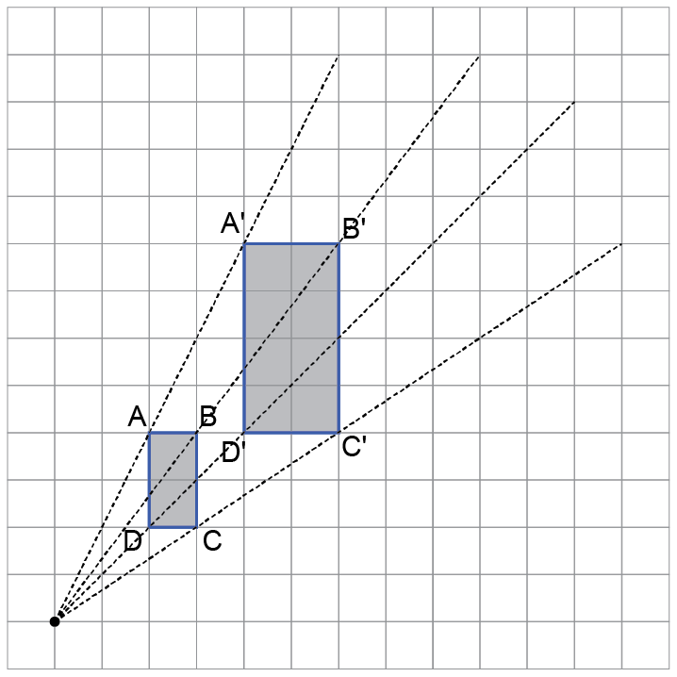  I drew a line from the dilation point to vertex A. Then, I extended the length of line to 2 times that length and placed the vertex A'. I repeated the process to get rectangle A'B'C'D'. | Describes and performs dilations on a coordinate grid (first quadrant)  Dilate ΔABC by a scale factor of $\frac{1}{3}$.  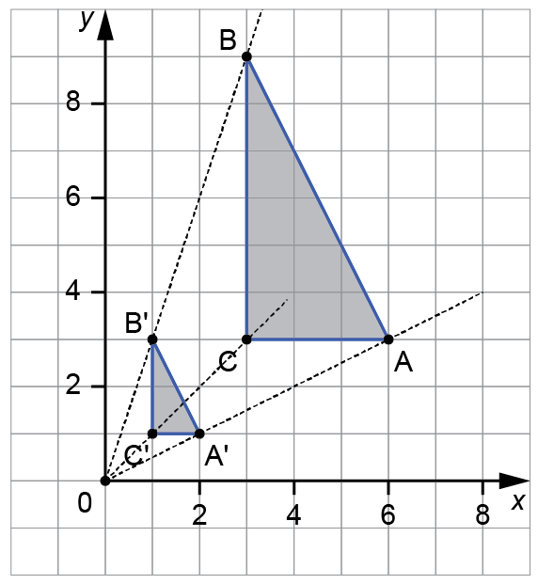  I drew a line from the dilation point to vertex A. Then, divided the length of line by 3 and placed the vertex A'.  I repeated the process to get ΔA'B'C'. I noticed that the coordinates of the vertices of the dilated image were one third those of the original triangle. For example, A(6, 3) moves to  A'(2, 1).

Observations/Documentation

