Transformations on the Cartesian Plane
Identifies and describes transformations on a Cartesian plane  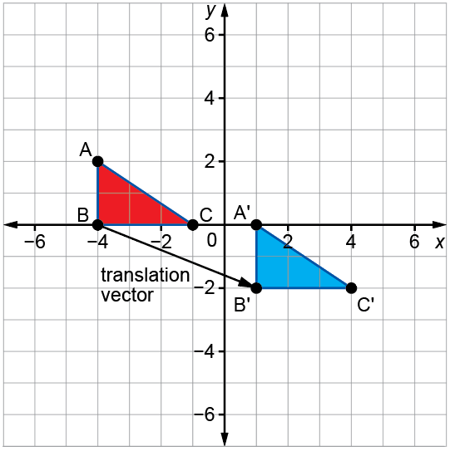  This shows ∆ABC is translated right  5 units and down 2 units to create ∆A'B'C'. | Describes and performs single transformations on a Cartesian plane  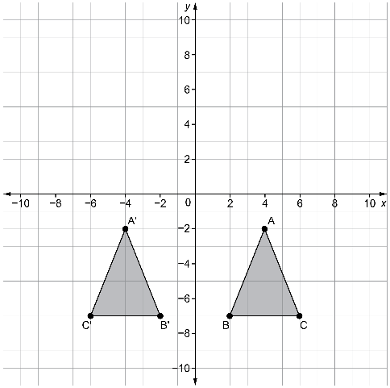  This is a reflection in the y-axis. | Uses patterns to describe and perform single transformations  on a Cartesian plane  A(4, –2) → A'(–4, –2)  B(6, –7) → B'(–6, –7)  C(2, –7) → C'(–2, –7)  The pattern in the coordinates is  (x, y) → (–x, y). | Describes and performs combinations of transformations  on a Cartesian plane  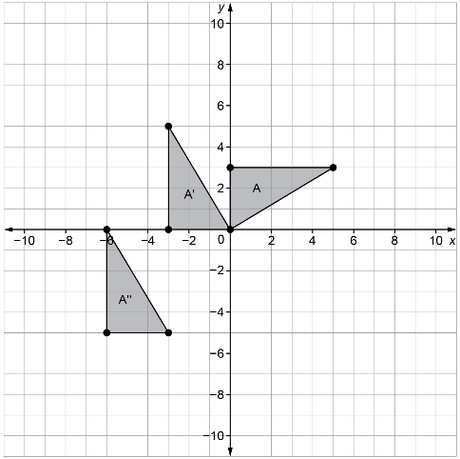  The triangle is rotated 90° counterclockwise around the origin, then translated left 3 units and down 5 units.

Observations/Documentation

