Calculating the Area of a Circle
Understands the relationships between radius, diameter, and area of a circle  I can make a polygon out of a circle by cutting the circle into equal segments and rearranging them into a parallelogram. Half the circumference, or $π$r, is the base and r is the height.  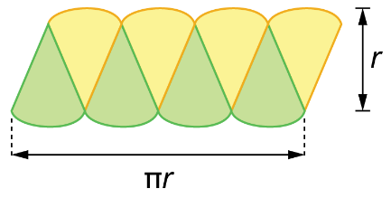 | Calculates the area of a circle,  given its radius  What is the area of a circle with radius of 2 cm?  I used the area formula for a circle.  3.14 × 2² = 12.56  The area is about 12.56 cm². | Calculates the area of a circle,  given its diameter  What is the area of a circle with diameter of 6 cm?  I found the radius first and then,  the area.  6 ÷ 2 = 3  The radius is 3 cm.  3.14 × 3² = 28.26  The area is about 28.26 cm². | Uses circle area formula to solve problems  Determine the area of a pizza with  a circumference of 94.2 cm.  I found the diameter first, then the radius, and finally the area.  94.2 ÷ 3.14 = 30  The diameter is about 30 cm.  30 ÷ 2 = 15  The radius is about 15 cm.  3.14 × 15² = 706.5  The area is about 706.5 cm².
Observations/Documentation

