Exploring Circles
Understands the relationship between radius and diameter of  a circle  If the diameter of a circle is 12 cm, what is its radius?  Since the diameter is double the radius, then the radius is 12 ÷ 2,  or 6 cm. | Understands relationships among radius, diameter, and circumference of a circle  If the radius of a circle is 6 cm,  what is its circumference?  I know that the circumference of  a circle is about 6 times its radius.  So, the circumference is 6 × 6,  or about 36 cm. | Constructs circles given the radius, diameter, or circumference  Draw a circle with a diameter of  12 cm.  The radius is 12 ÷ 2, or 6 cm. I used a ruler to set the compass to 6 cm. Then, drew the circle.  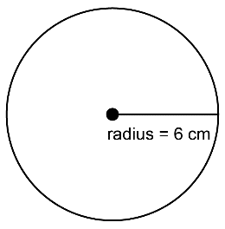 | Uses relationships among circle measures to solve problems  Determine the circumference of  a pizza with a diameter of 30 cm.  I used the relationship circumference = diameter × 3.14 to get a circumference of about 94.2 cm.
Observations/Documentation

