Unit Conversions
Understands the relationship among metric units of length and area  1 m²: $12.99  100 cm²: $10.99  I can visualize a square with 1 m side lengths. Since 1 m = 100 cm,  there are 100 cm² in just one row  of a square metre. So, 1 m² has  100 rows of 100 cm².  1 m² = 10 000 cm².  The 1 m² flag is much larger. | Uses metric relationships to convert from smaller to larger units to solve problems  40 000 cm² = ________ m²  I know 1 m² = 10 000 cm².  I can use a ratio table to find  40 000 cm² = 4 m².  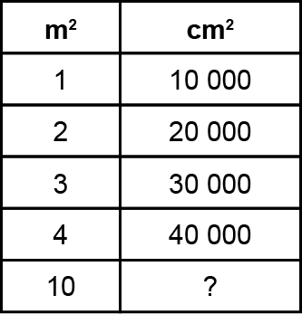 | Uses metric relationships to convert from larger to smaller units to solve problems  5000 cm² = ______ mm²  I know 1 cm² = 100 mm².  I can use ratios to find 5000 cm² = 500 000 mm².  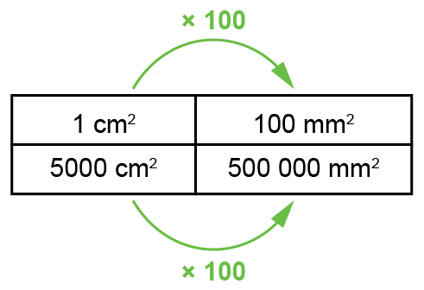 | Uses metric relationships to solve problems  A table top has an area of 2 m². Would 700 square tiles with 5 cm sides be enough to cover  the table top?  I converted the area of table:  2 m² = 20 000 cm².  Then, I calculated the area of  the tiles:  5 × 5 × 700 = 17 500 cm²  Since 17 500 cm² < 20 000 cm², there are not enough tiles to cover the table top.
Observations/Documentation

