Investigating Properties
of Similar Shapes
Geometry
Unit 1 Line Master 6a

1. Determine the scale factor that was used to dilate
the original shape.
Compare the properties of each pair of similar shapes.
What properties do dilations seem to have? Make a list.
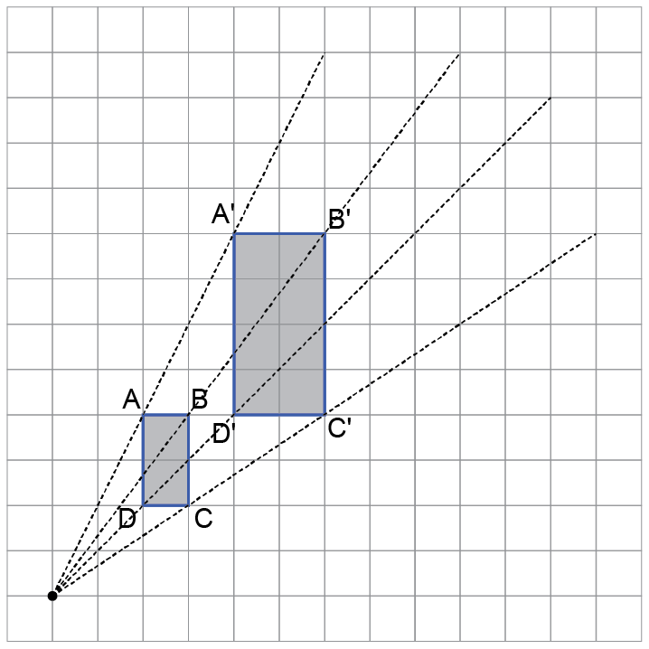
a)
dilation point
Scale Factor = _______

Investigating Properties
of Similar Shapes (cont’d)
Geometry
Unit 1 Line Master 6b

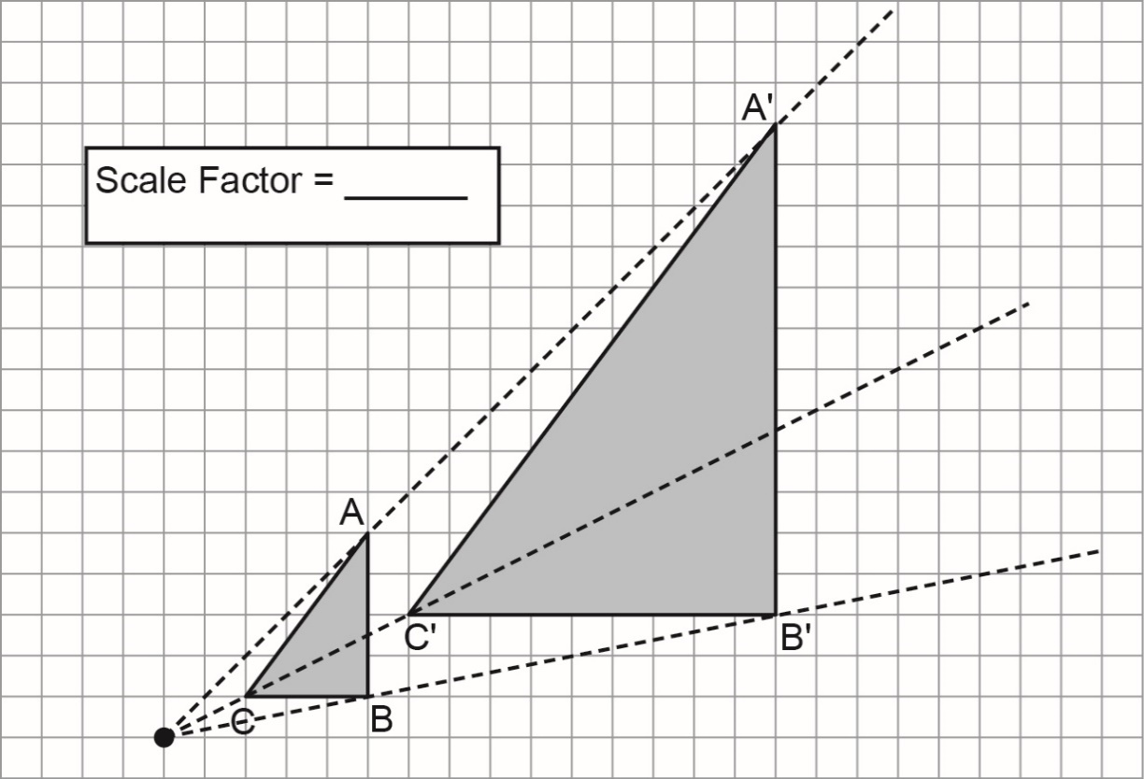
b)

dilation point

Investigating Properties
of Similar Shapes (cont’d)
Geometry
Unit 1 Line Master 6c

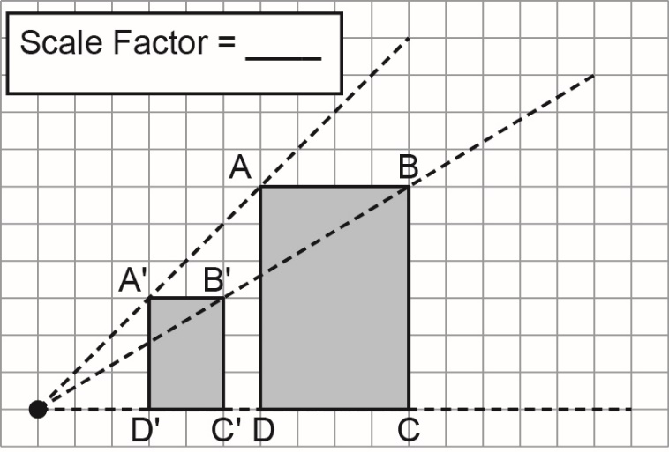
c)

dilation point

Investigating Properties
of Similar Shapes (cont’d)
Geometry
Unit 1 Line Master 6d

2. Use the scale factor and the dilation point to create a dilation
of the triangle. Check to see if the properties you found in
Question 1 hold true for your dilation.

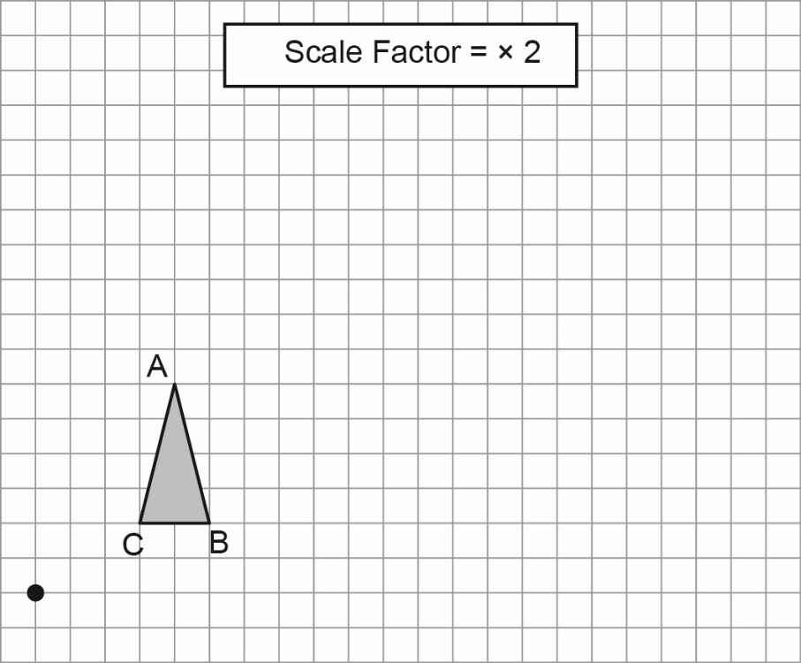
dilation point

