**Geometry**

**Unit 1 Line Master 5a**

Pattern Block Cut-Outs

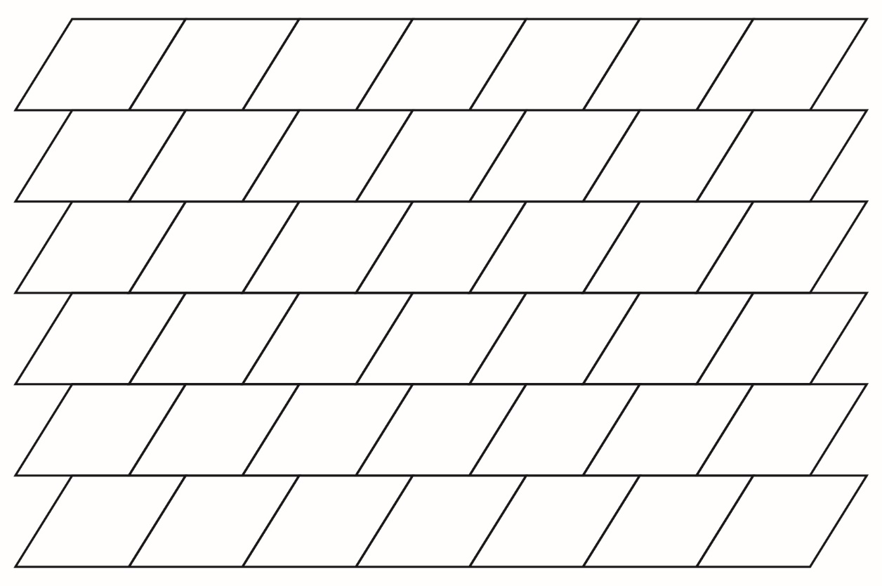

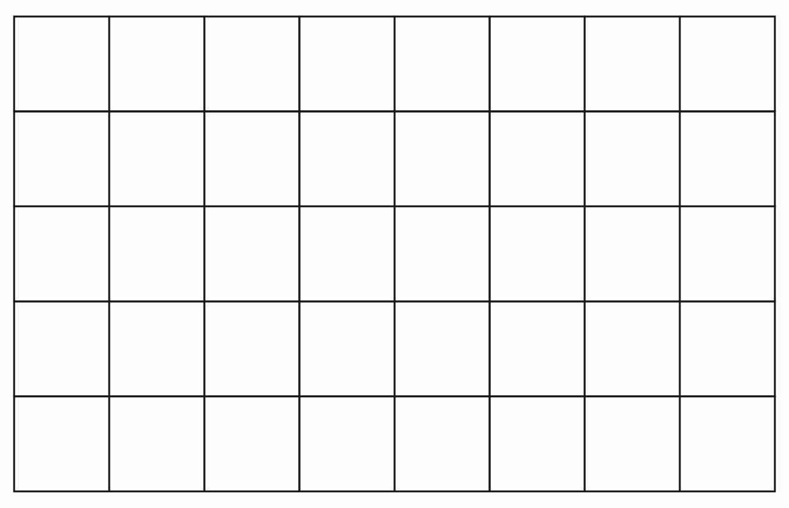

**Geometry**

**Unit 1 Line Master 5b**

Pattern Block Cut-Outs (cont’d)

