Probability of Two Dependent Events
Calculates theoretical probability for 2 dependent events  Two tiles are removed from the bag.  Sample space:  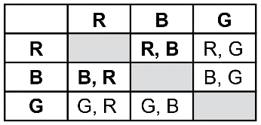  For red and blue, there are 2 favourable outcome and 6 possible outcomes, so  the theoretical probability of red  and blue is: $\frac{2}{6}$ or $\frac{1}{3}$ | Calculates experimental probability for 2 dependent events  Two tiles are removed from the bag.  The results for 10 trials:  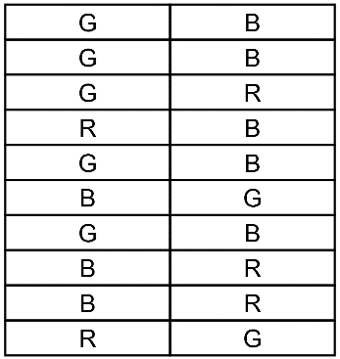  The outcome, red and blue, occurred 3 times, and the experiment was conducted 10 times, so the experimental probability of red and blue is:  $\frac{3}{10}$ = 0.3 = 30% | Compares experimental and theoretical probabilities for 2 dependent events  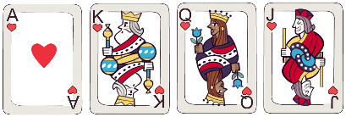  Two cards are removed.  Sample space for two dependent events  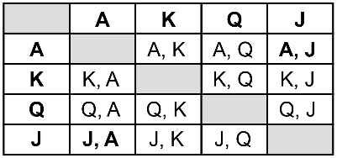  Theoretical probability for an Ace  and a Jack is: $\frac{2}{12}$ = $\frac{1}{6}$  The results for 12 trials:  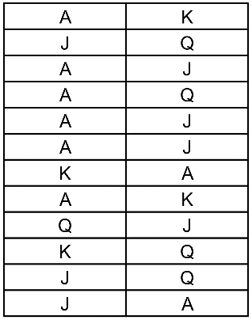 | Understands how the experimental and theoretical probabilities are affected by many trials  For 100s of trials of an experiment, the experimental probability of an outcome may approach its theoretical probability.

Experimental probability for an Ace

and a Jack is: $\frac{4}{12}$ = $\frac{1}{3}$
The experimental probability is greater than the theoretical probability.

Observations/Documentation

