Probability of Two Independent Events
Calculates theoretical probability for 2 independent events  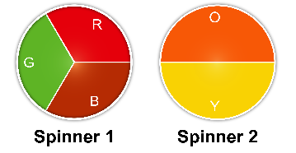  Spinning the pointer on each  spinner once  Sample space:  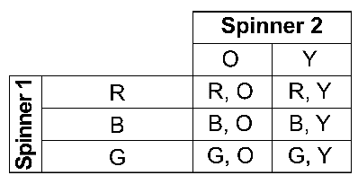  For green and orange, there is 1 favourable outcome and 6 possible outcomes, so  the theoretical probability of green and orange is: $\frac{1}{6}$ | Calculates experimental probability for 2 independent events  Spinning the pointer on each  spinner once  The results for 10 trials:  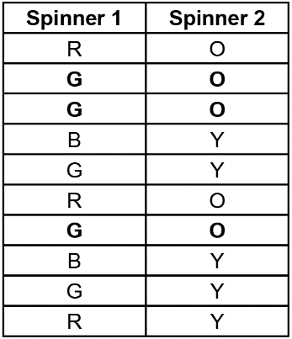  The outcome, green and orange, occurred 3 times, and the experiment was conducted 10 times, so the experimental probability of green and orange is:  $\frac{3}{10}$ = 0.3 = 30% | Compares experimental and theoretical probabilities for the same experiment  Tossing two coins  The results for 10 trials  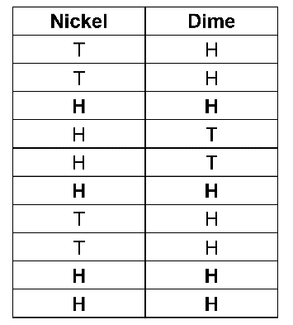  Sample space  Experimental probability of 2 heads is: $\frac{4}{10}$ = 0.4 = 40%  Theoretical probability of 2 heads is:  $\frac{1}{4}$ = 0.25 = 25%  The experimental probability is greater than the theoretical probability. | Understands how the experimental and theoretical probabilities are affected by many trials  For 100s of trials of an experiment, the experimental probability of an outcome may approach its theoretical probability.

Observations/Documentation

