Exploring Independent and Dependent Events
Understands and explains independent events  The outcome of one event does not affect the outcome of the other event, for example, removing a marble from a bag, then replacing it before a second marble is taken. | Identifies the sample space for two independent events  A marble is taken from the bag, replaced, and then a second marble is taken.  What is the sample space?  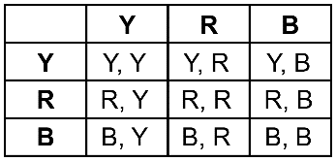 | Understands and explains dependent events and their sample space  The outcome of one event affects the outcome of the other event, for example, removing a marble from a bag, and not replacing it before a second marble is taken.  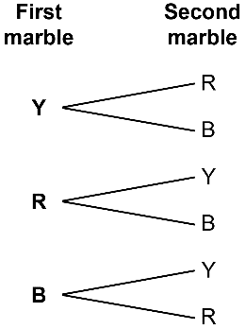  The sample space is:  Y, R; Y, B; R, Y; R, B; B, Y; B, R | Determines the probability  of two events  For the two independent events, the theoretical probability of picking red  and blue marbles is: $\frac{2}{9}$  For the two dependent events,  the probability of picking red and  blue marbles is: $\frac{2}{6}$ = $\frac{1}{3}$

Observations/Documentation

