Creating an Infographic
Explains what an infographic is  An infographic is a set of graphs, tables, and pictures that shows information about a topic. | Interprets an infographic  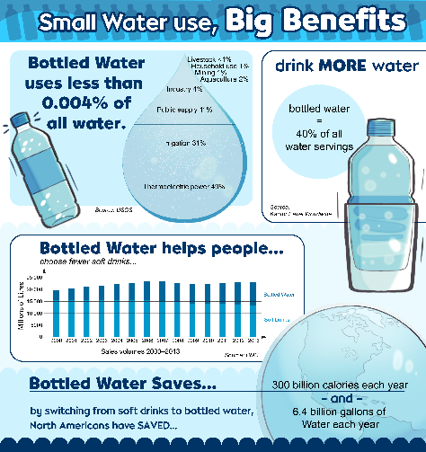  “I think the infographic wants me to believe that the best way to buy water is in plastic bottles.” | Collects data for an infographic  “I chose the topic, “It is important for students to eat well to live a healthy lifestyle.”  “I want to collect qualitative and quantitative data from both primary and secondary sources. I will organize the data in tables, including relative frequency tables.” | Creates an infographic  "I created an infographic on the importance of eating well to live a healthy lifestyle. I included pictures, bar graphs, circle graphs, lots of colour, and few words to help tell  my story."
Observations/Documentation

