Analysing and Critiquing Given Data
Analyses and interprets a given graph  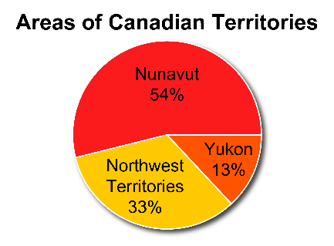  The Northwest Territory is about one-third of the total area of the territories.  Nunavut is a bit more than one-half of the total area of the territories. | Identifies misleading information in a graph  Birds at a Feeder  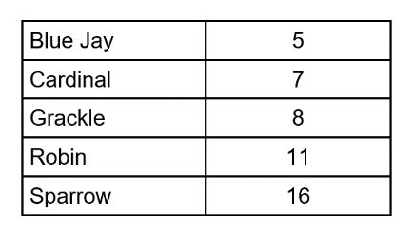  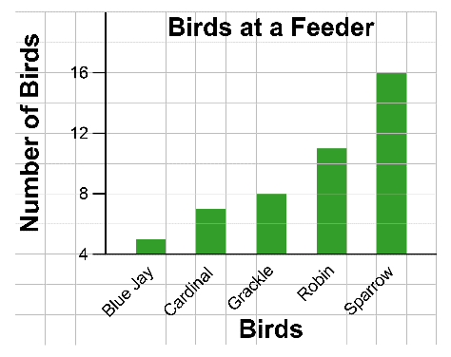  There are twice as many sparrows as grackles, but the graph appears to show that there are three times as many sparrows as grackles. | Corrects the bias shown in a given graph  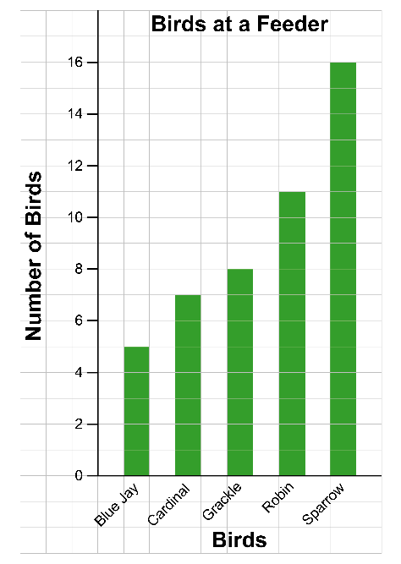  “I redrew the graph with the vertical axis starting at 0 to remove the bias.” | Constructs a graph to show bias  Populations of 5 largest Ontario cities, to the nearest 100 000  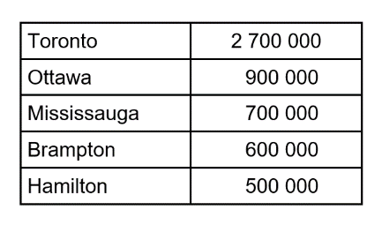  Biased graph  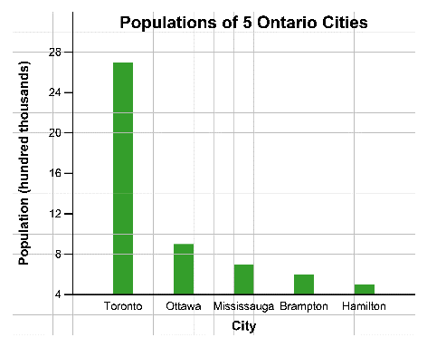

Observations/Documentation

