Presenting Data Graphically
Creates different types of graphs  "I created a bar graph."  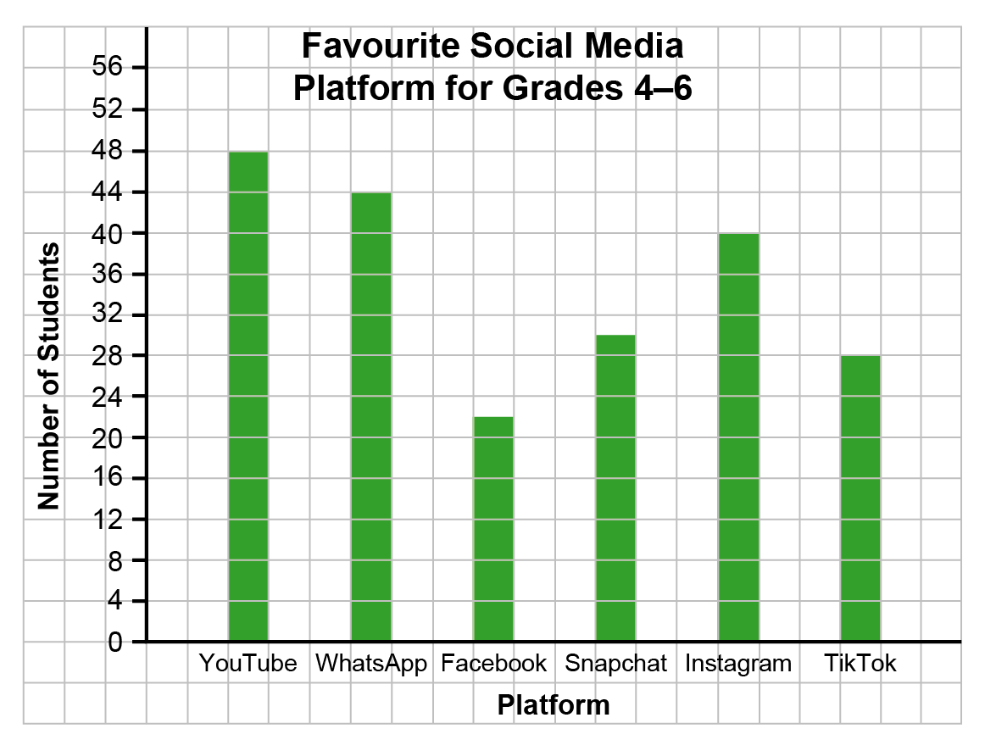  I created a broken-line graph.  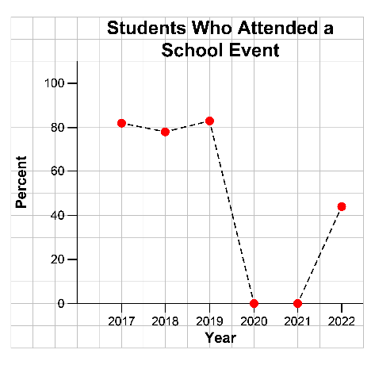 | Uses the given data to decide on the type of graph to draw, and justifies the choice  “I created a bar graph to show the number of coin tosses I made each minute for 5 minutes. Because the number of coin tosses each minute was discrete data, I needed to use separate bars for each minute.”  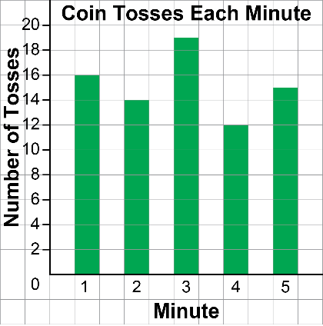 | Asks and answers questions about  a graph  "Question:  What was the total number of coin tosses made in 5 minutes?  Answer:  The sum of all the bar heights is:  16 + 14 + 19 + 12 + 15 = 76  The total number of coin tosses made in 5 minutes was 76." | Suggests an alternative graph to display a given data set  “For the coin toss data, I could have used a picture of a coin to represent 1 toss and created a pictograph.”

Observations/Documentation

