Using Code to Simulate Probability Experiments
Executes code that is provided and describes results  “When I click the green flag, the Coin Toss application tosses a coin and shows whether it is heads or tails. I can execute it many times to simulate lots of tosses.” | Reads and interprets code, predicting the output  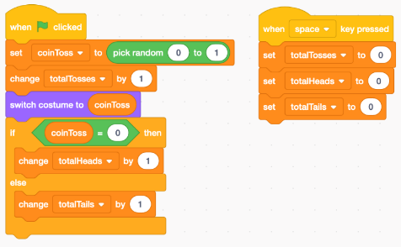  “This application simulates tossing a coin by picking either 0 or 1 at random and shows whether heads or tails is tossed. If I execute it lots of times, I should get heads about half the time.” | Understands the use of subprograms and repeats in programs  “By adding the repeat to the Coin Toss application, it makes it much easier to use. Instead of pressing the green flag lots of times, I can just simulate many trials by changing the repeat number to a large number.” | Writes and debugs code to determine experimental probabilities  “Once the program has simulated tossing the coin 1000 times, I can use the results to calculate the experimental probability of tossing tails. I’ll create a variable called tailsEP and set it to be equal to the number of tails tossed divided by the total number of tosses. The code is:  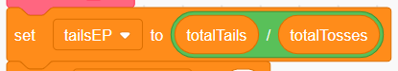
Observations/Documentation

