Using Code to Calculate Area and Volume
Executes code that is provided and interprets results  “When I click on the green flag,  the Area of a Rectangle application asks me to enter a length and width in centimetres. When I do this, the program outputs the area in square centimetres.” | Reads and interprets pseudocode, completing or altering as needed  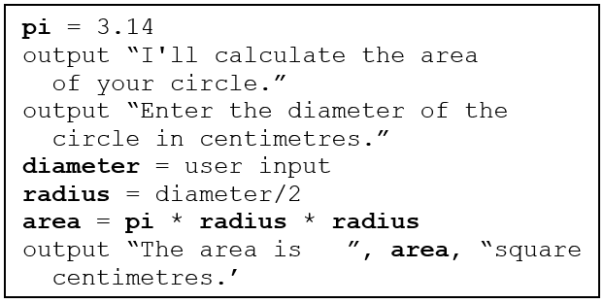  “The program this pseudocode describes calculates the area of  a circle when a user enters a diameter.  To create code for this, I need to make 4 variables:  pi, diameter, radius, and area” | Reads and interprets code, completing or altering as needed  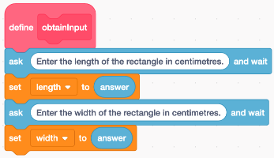  “The first subprogram I created gets information from the user and stores it in the correct variables. These variables are used in the subprogram that calculates the area. My last subprogram outputs the calculated area on the stage.” | Writes code to calculate area  or volume  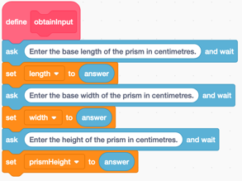  "I renamed the length, width, and area variables to base length, base width, and base area. I created a prism height variable and added a prompt asking for it. I added a subprogram calculating the volume."
Observations/Documentation

