Using Code to Perform Transformations
Executes code that is provided and interprets results  When I click on the green flag, the Plotting Triangles application draws a blue triangle on a coordinate plane. | Reads and interprets pseudocode, completing or altering as needed  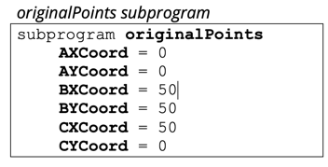  This subprogram identifies the coordinates of the vertices. It is called up in the main program so the sprite knows what points to move to. | Reads and interprets code for translations, completing or altering as needed  How did you write a subprogram that would translate the triangle vertically?  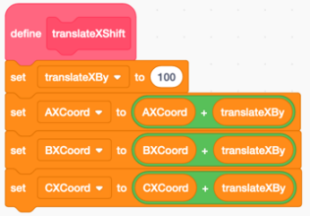  This subprogram shifts the triangle 100 units to the right. To move it 100 units to the left, I would change the 100 to –100 in this subprogram. | Writes and debugs code to perform translations on the coordinate plane  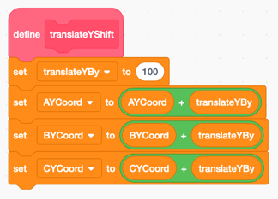  I used the same blocks as the subprogram to translate horizontally but I made a new variable translateYBy and changed the  y-coordinates instead of the  x-coordinates.
Observations/Documentation

