Using Code to Generate Linear Patterns
Executes code that is provided and interprets results  “When I clicked the green flag, the program output the numbers 0, 3, 6, 9, 12, 15 in a list. The terms in this pattern increase by 3 each time.” | Reads and interprets pseudocode, completing or altering as needed  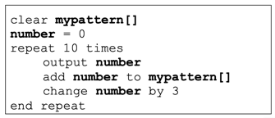  “This pseudocode is for a program to output 10 terms of a pattern that starts with 0 and increases by 3 each time. To output a pattern that increases by 4 each time, replace the 3 in the change number line to 4.” | Reads and interprets code, completing or altering as needed  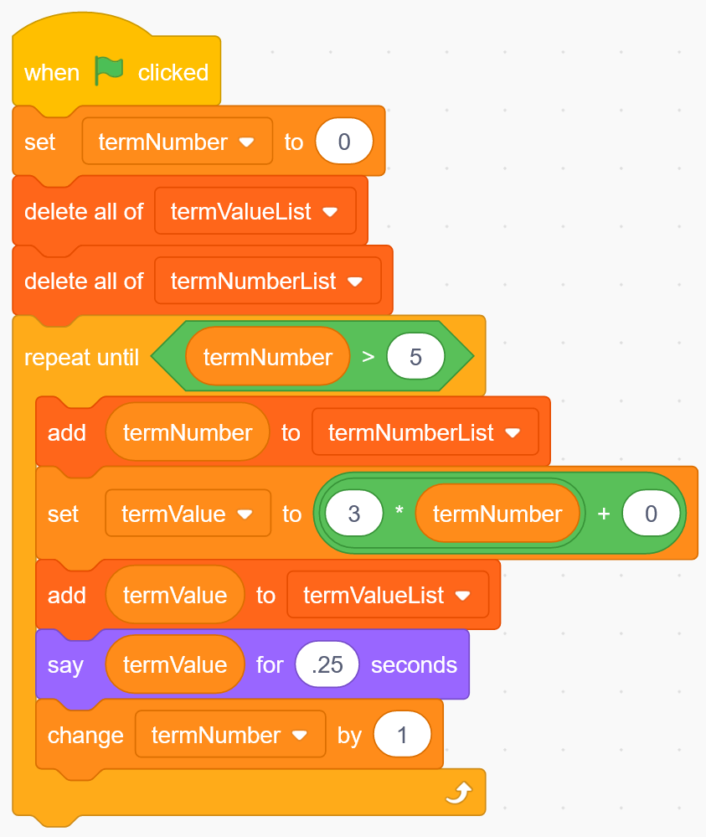  “This code will display 6 terms of a pattern that starts at 0 and increases by 3 each time. To display 6 terms of a pattern that starts at 1 and increases by 5 each time, leave the repeat until block the same but change the expression in the set termValue block to 5*termNumber + 1.” | Analyses output data to help solve problems  “The output of the code gives me lots of data about the cost to buy different numbers of records. I can see that the price per record drops really quickly to begin with, but then more slowly. To make it worthwhile to pay the high shipping fee, I would buy at least 30 records. After 30, the unit price decrease isn’t as good. Since Ty is buying for a business, they will likely find lots of albums to purchase.”
Observations/Documentation

