Writing Code to Calculate the
Volumes of Prisms and Cylinders

Algebra
Unit 3 Line Master 9a

So far, you’ve written code for applications that calculate the
area of rectangles and circles.
These are two-dimensional shapes, which is why the areas are measured in square units, such as square centimetres (cm²).

When you start to work with 3-D objects, such as prisms and cylinders, you can visualize creating an object by stacking copies of the base in layers that are each 1 unit tall until you reach the height.
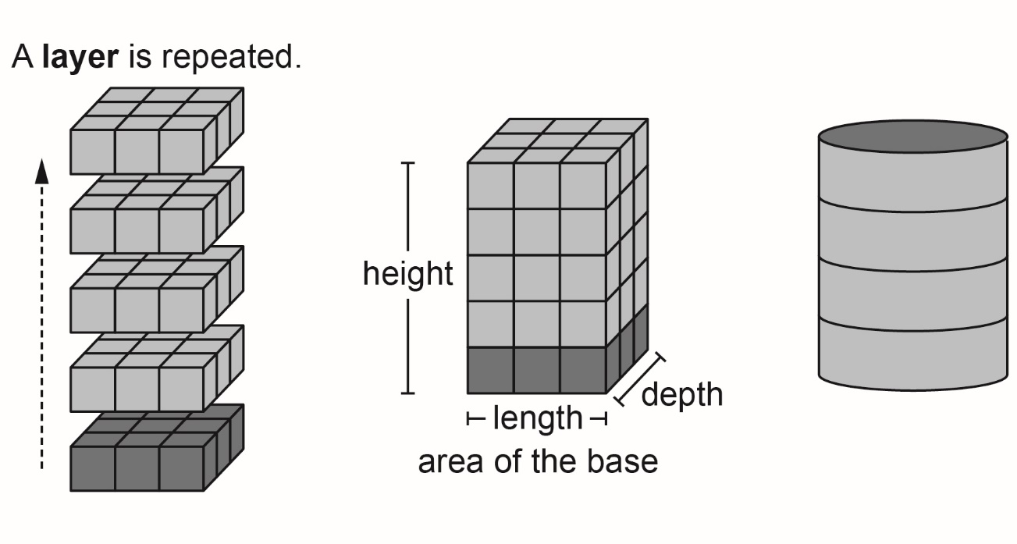
From the diagrams, you can see that the volume of each object
is equal to the area of the base multiplied by the height.
volume = base area $×$ height
Because you are multiplying three dimensions (the base length, base width, and height), volumes are measured in cubic units, such as cubic centimetres (cm³).
Writing Code to Calculate the
Volumes of Prisms and Cylinders (cont’d)

Algebra
Unit 3 Line Master 9b

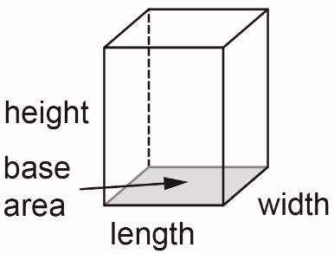
Part 1: Calculating the Volume of a Rectangular Prism
When the base of a prism is a rectangle,
we call it a rectangular prism.
In code, the formula for the area of a
rectangular prism is:
volume = baseArea * height

Here’s a link to the application you created in Scratch that uses subprograms to calculate the area of a rectangle.

https://scratch.mit.edu/projects/805451173/editor/

You will modify the application by adding a volume calculation.
Go to the link and alter the code, based on the pseudocode provided on the following page.

The dimensions of the rectangle that the user enters now represent the dimensions of the base of a rectangular prism. You will need to add blocks to the obtainInput subprogram to ask the user to enter a height as well.

Notice in the pseudocode, the variable called area in the rectangle application is renamed baseArea.

To rename a variable, right click on the variable name under Variables and select Rename variable and enter the new name.
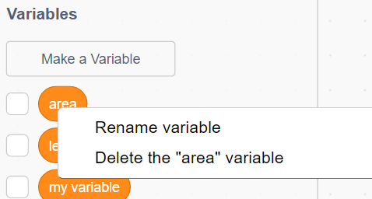

Writing Code to Calculate the
Volumes of Prisms and Cylinders (cont’d)

Algebra
Unit 3 Line Master 9c

Pseudocode: Calculating the Volume of a Rectangular Prism
Obtain Input Subprogram
subprogram obtainInput
output “Enter the base length of the prism in centimetres:”
length = user input
output “Enter the base width of the prism in centimetres:”
width = user input
output “Enter the height of the prism in centimetres:”
height = user input

Calculate Base Area Subprogram
subprogram calculateArea
baseArea = length * width

Calculate Volume Subprogram
subprogram calculateVolume
volume = baseArea * height

Output Info Subprogram
subprogram outputInfo
output “The base area is “, baseArea, “ square centimetres.”
output “The volume is “, volume, “ cubic centimetres.”

Main Program
output “I'll calculate the volume of your rectangular prism.”
run obtainInput subprogram
run calculateArea subprogram
run calculateVolume subprogram
run outputInfo subprogram

Writing Code to Calculate the
Volumes of Prisms and Cylinders (cont’d)

Algebra
Unit 3 Line Master 9d

Your main program should look like this when completed:
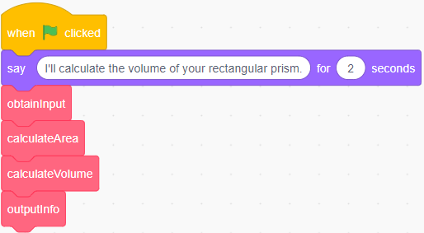
1. Try out your application by using it to determine the volume
of a rectangular prism with each set of dimensions.
The first one can be calculated mentally and serves as a way
to check whether your code is correct.
a) length: 10 cm, width: 10 cm, height: 10 cm
b) length: 25 cm, width: 17 cm, height: 8 cm
c) length: 125 cm, width: 64 cm, height: 32 cm

Writing Code to Calculate the
Volumes of Prisms and Cylinders (cont’d)

Algebra
Unit 3 Line Master 9e

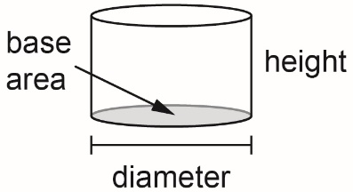
Part 2: Calculating the Volume of a Cylinder

Here is an image of the completed Scratch
code for an application to calculate the volume
of a cylinder:
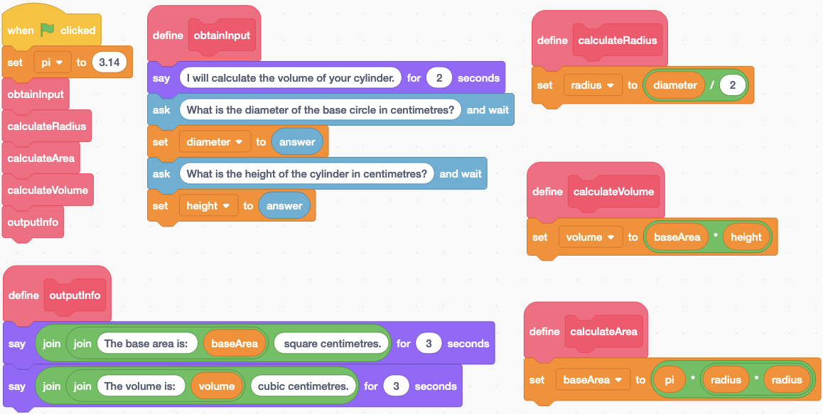

1. Pseudocode for this application is provided here and on the
next page but some parts are missing.
Fill in the blanks to complete the missing parts.
Obtain Input Subprogram
subprogram obtainInput
output “What is the diameter of the base circle in
centimetres?”
diameter = user input
output “What is the height of the cylinder in
centimetres?”
height = user input

Calculate Radius Subprogram
subprogram calculateRadius
radius = diameter/2
Writing Code to Calculate the
Volumes of Prisms and Cylinders (cont’d)

Algebra
Unit 3 Line Master 9f

Calculate Base Area Subprogram
subprogram calculateArea
baseArea = pi * radius * radius

Calculate Volume Subprogram
subprogram calculateVolume

__________________________

Output Info Subprogram
subprogram outputInfo
output “The area is “, baseArea, “ square centimetres.”
output “_________________________________________”

Main Program
pi = 3.14
output “I'll calculate the volume of your cylinder.”
run _____________ subprogram
run _____________ subprogram
run _____________ subprogram
run _____________ subprogram
run _____________ subprogram

2. Here is a link to the completed application for calculating
the volume of a cylinder in Scratch.
https://scratch.mit.edu/projects/805563755/editor/

Use the application to determine the volume of a cylinder
with each set of dimensions.
a) diameter: 20 cm, height: 10 cm
b) diameter: 34 cm, height: 50 cm
c) diameter: 120 cm, height: 88 cm
Writing Code to Calculate the
Volumes of Prisms and Cylinders (cont’d)

Algebra
Unit 3 Line Master 9g

Additional Challenge
Write code for an application to calculate the volume of
a triangular prism.
You might find it helpful to begin by writing pseudocode.
As you plan your code, think about what information you
need to determine the area of the base triangle.
