Using Subprograms to
Organize Your Code

Algebra
Unit 3 Line Master 8a

Part 1: Application that Calculates the Area of a Rectangle

Let’s revisit the application that determined the area of a rectangle and reorganize the code by creating subprograms.

A subprogram contains a small set of instructions to complete a task
and is referenced and called to action by the main program.
In Scratch, when we make a new block, we have made a subprogram.

Use the link to the application you used to determine areas of rectangles in Master 7:

https://scratch.mit.edu/projects/805357000/editor/

If you have a Scratch login, save the project in your Scratch
account by selecting Remix at the top of the screen.
A login is not required to work with the code, but you will not
be able to save your changes without it.

This pseudocode shows how we will reorganize the application
into 3 subprograms and a main program that calls them up.

Obtain Input Subprogram
subprogram obtainInput
output “Enter the length of the rectangle in
centimetres:”
length = user input
output “Enter the width of the rectangle in
centimetres:”
width = user input

Calculate Area Subprogram
subprogram calculateArea
area = length * width

Let’s revisit the application that determined the area of a rectangle and reorganize the code by creating subprograms.
Using Subprograms to
Organize Your Code (cont’d)

Algebra
Unit 3 Line Master 8b

Output Info Subprogram
subprogram outputInfo
output “The area is “, area, “ square centimetres.”

Main Program
output “I'll calculate the area of your rectangle.”
run obtainInput subprogram
run calculateArea subprogram
run outputInfo subprogram

- Start by creating a subprogram containing the code that requests information about length and width from the user.

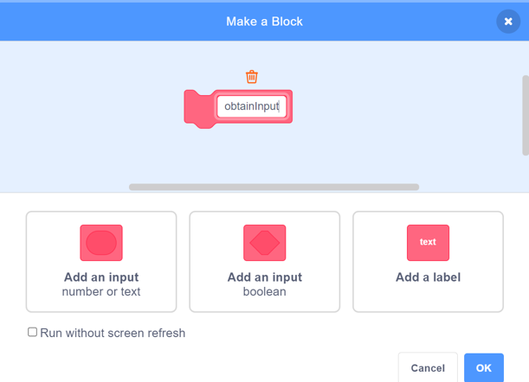
- To create a subprogram, select
My Blocks, Make a Block.
Name the first subprogram obtainInput and click OK.

- Pull apart the blocks from the original program.
Drag the relevant ask and set blocks so they appear beneath the obtainInput subprogram as shown here.
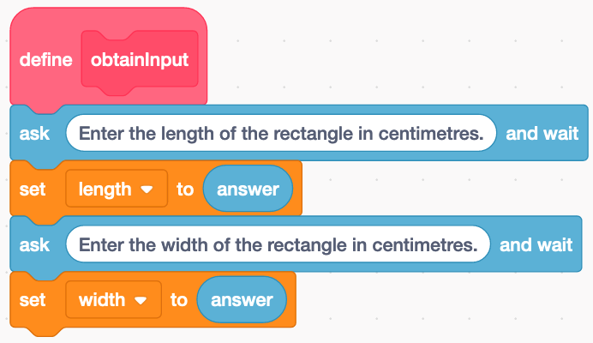

Using Subprograms to
Organize Your Code (cont’d)

Algebra
Unit 3 Line Master 8c

- Create a second subprogram called calculateArea.
Drag the set area calculation code to appear beneath it.
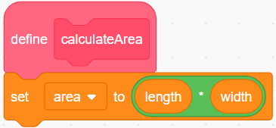
3. Create a third subprogram called outputInfo.
Drag the say block that states the calculated area to appear
beneath it.
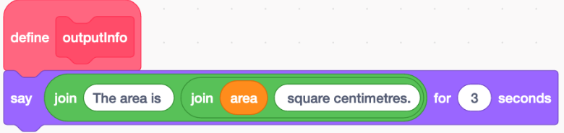
4. Now you can adjust your main program to “call” the subprograms
into action, as shown below.
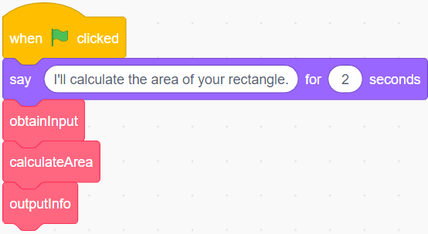
- You have broken down the main program into smaller, more manageable steps. This means there is less code in the main program. It also helps to clarify what is happening in each part.
- If you need to debug or correct errors in the application, you can focus on one of the subprograms rather than having to look at all of the code at once.
- Try the application with dimensions you used in Part 1 of Master 7 to confirm it outputs the correct areas.
Using Subprograms to
Organize Your Code (cont’d)

Algebra
Unit 3 Line Master 8d

Part 2: Application that Calculates the Area of a Circle

Now that you know how to create subprograms, you can incorporate subprograms into the application you used to calculate the area
of a circle in Master 7. Use this link to the application without subprograms:

https://scratch.mit.edu/projects/805564875/editor/

Create subprograms for each part of the application.
Follow the pseudocode provided below. Be sure to name your subprograms based on the names used in the pseudocode.
Check your revised program using diameters from Part 2 of Master 7.
Obtain Input Subprogram
subprogram obtainInput
output “Enter the diameter of the circle in
centimetres:”
diameter = user input

Calculate Radius Subprogram
subprogram calculateRadius
radius = diameter/2

Calculate Area Subprogram
subprogram calculateArea
area = pi * radius * radius

Output Info Subprogram
subprogram outputInfo
output “The area is “, area, “ square centimetres.”

Main Program
pi = 3.14
output “I'll calculate the area of your circle.”
run obtainInput subprogram
run calculateRadius subprogram
run calculateArea subprogram
run outputInfo subprogram

