Using Code to Calculate the Areas
of Rectangles and Circles

Algebra
Unit 3 Line Master 7a

Part 1: Area of a Rectangle
Let’s take a look at a Scratch application that determines the area
of a rectangle based on dimensions input by the user.
Click on this link to access the application:
https://scratch.mit.edu/projects/805357000/editor/

Here’s the code that you will see:
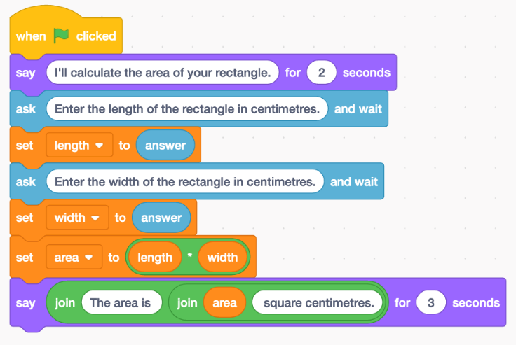
If you have a Scratch login, save the project in your Scratch account by selecting Remix at the top of the screen.
A login is not required to work with the code, but you will not be able to save your changes without it.
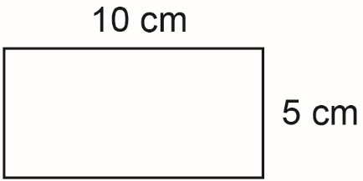
1. Without using the application, calculate the area of a rectangle
with length 10 cm and width 5 cm.
How did you determine the answer?
Using Code to Calculate the Areas
of Rectangles and Circles (cont’d)

Algebra
Unit 3 Line Master 7b

2. Click on the green flag above the stage to execute the application.
When the program asks for input, enter 10 for the length and 5
for the width. Click on the checkmark symbol or press return to
enter each dimension.
Your output should look like the one below.
Does the calculated area agree with your answer to Question 1?
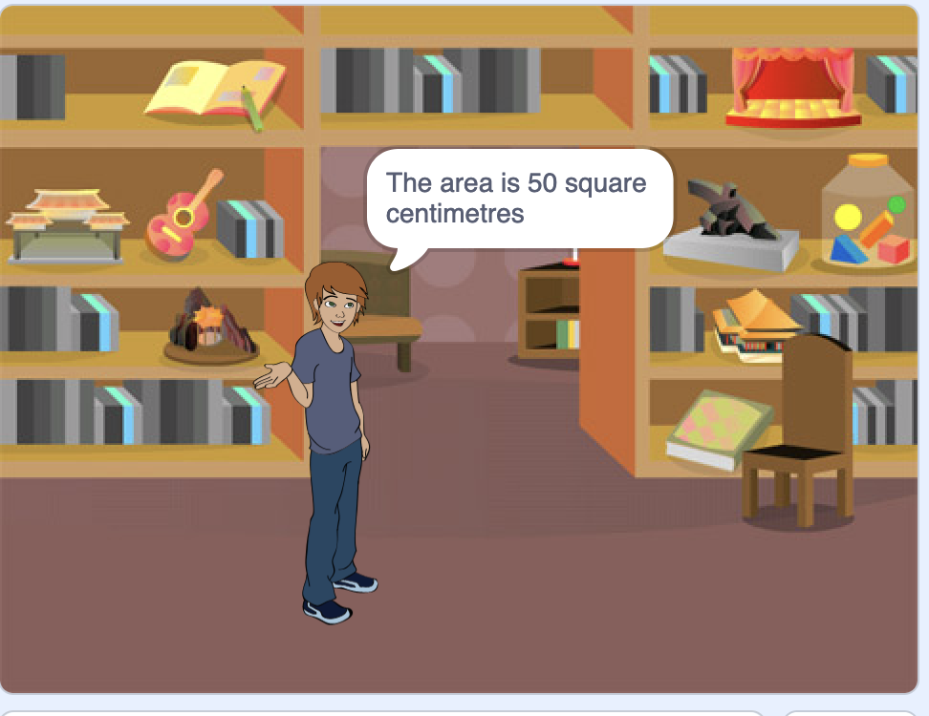

3. Use the program to determine the area of rectangles
with these dimensions.
a) length 15 cm, width 7.5 cm
b) length 24 cm, width 9 cm
c) length 105 cm, width 57 cm

4. List all the possible pairs of whole number dimensions for
a rectangle with an area of 36 cm².
Input some of your answers in the program to verify they
are correct.

Using Code to Calculate the Areas
of Rectangles and Circles (cont’d)

Algebra
Unit 3 Line Master 7c

Next, let’s look at the pseudocode for this program.
Pseudocode is an informal way of describing a computer program—
it is somewhere between everyday language and programming code.
Computer programmers, or coders, often use pseudocode when planning
their programs.

Pseudocode for Calculating Area of a Rectangle Program
output “I will calculate the area of your rectangle.”
output “Enter the length of the rectangle in
centimetres:”
length = user input
output “Enter the width of the rectangle in centimetres:”
width = user input
area = length * width
output “The area is “, area, “ square centimetres.”

5. How would you change this pseudocode so that the instructions
for the user asks for metres rather than centimetres?
Alter the Scratch code to reflect this change now.

Part 2: Area of a Circle
Let’s write similar code to calculate the area of a circle.
Here’s the pseudocode for calculating the area of a circle.
pi = 3.14
output “I will calculate the area of your circle.”
output “Enter the diameter of the circle in centimetres:”
diameter = user input
radius = diameter/2
area = pi * radius * radius
output “The area is “, area, “ square centimetres.”

Using Code to Calculate the Areas
of Rectangles and Circles (cont’d)

Algebra
Unit 3 Line Master 7d

If you have prior experience coding in Scratch, you may go ahead
and create the Scratch application now.
Otherwise, take a look at the code below.
You can use the link below to open an application that contains
only a stage backdrop and sprite.
If you prefer, you can open a new Scratch file of your own
and select a backdrop and sprite of your choice from the area
just below the stage.
https://scratch.mit.edu/projects/805563622/editor/
Recreate the code shown below. If you are uncertain where to
find or how to use any of the blocks, take a look at the coding tips.
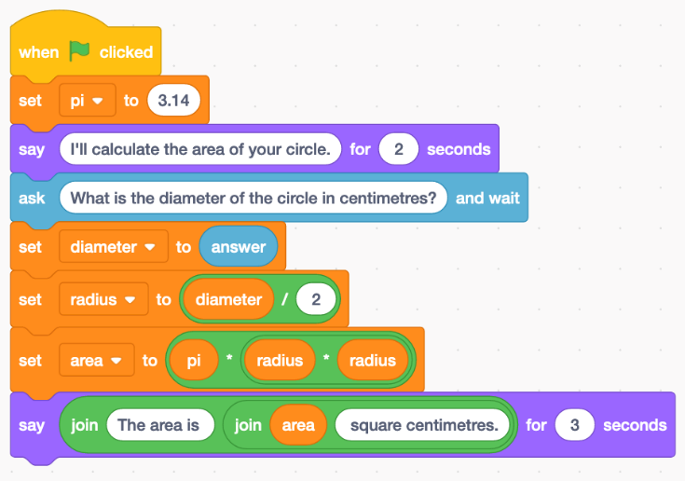
Coding Tips
Variables
- To create variables, go to Variables, Make a variable.
- The four variables needed for this application are diameter, radius, area, and pi.
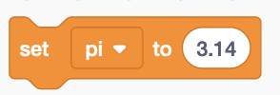
- Use a set block to set the pi variable to 3.14.

Using Code to Calculate the Areas
of Rectangles and Circles (cont’d)

Algebra
Unit 3 Line Master 7e

Say and join blocks
- The say block is found under Looks.
- For the first say block, you just need to enter the speech
bubble text.
- When you come to create the second say block at the end
of the program, you will use two join blocks inside each other.
These can be found under Operators.
Join blocks allow you to say more than one thing inside of
a speech bubble, which is useful when you’d like to output the value of a variable, such as area, a long with some text.
Complete the say block as shown.
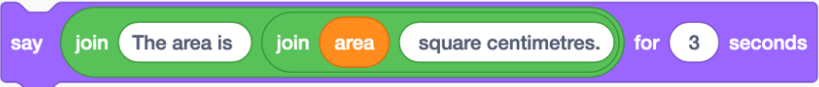

Ask and Wait Blocks
- The ask and wait block can be found under Sensing.
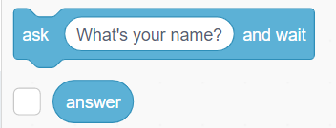
- You will need both the ask and wait block,
as well as the answer block found beneath it.
- Enter the prompt that you want to appear in
the speech bubble.
- Use a set block to set the diameter to the answer.

Operators
- To determine the radius, retrieve a
division operator from under Operators.
- Snap this into the set block found under Variables,
with the radius variable selected in the pulldown menu.

Using Code to Calculate the Areas
of Rectangles and Circles (cont’d)

Algebra
Unit 3 Line Master 7f

- Drag the diameter variable into the first oval and enter
the number 2 as shown.
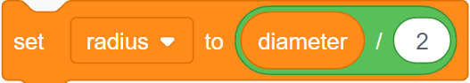
- To calculate the area, you will need two multiplication operators.
Place one inside of the other.
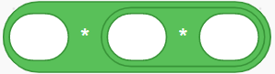
- Snap this into the set block found under Variables, with the area variable selected in the pulldown menu.
- Drag and insert the pi and radius variables as shown.
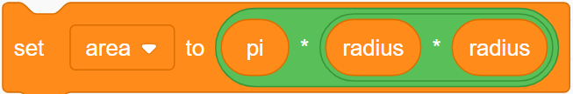
If you’re stuck, here is a link to the completed application.
https://scratch.mit.edu/projects/765438443/editor/

1. a) Use the formula A = $π$r² to determine the area of a circle with
diameter 20 cm. Remember that the radius is half the diameter.
b) Now use your Scratch application to determine the area of
a circle with diameter 20 cm.
c) Do your answers to parts a and b match? If they don’t check
your calculation and your code to look for errors.
The area should be 314 cm².

2. Once you are satisfied that your code is correct, use it to determine the area of a circle with each given diameter. Round each answer to the nearest square centimetre when necessary.
a) 12 cm b) 64 cm c) 120 cm

3. What is the benefit of having an application that can calculate
areas of rectangles or circles?

