Using Code to Transform
Triangles

Algebra
Unit 3 Line Master 6a

You will be creating new subprograms
by writing code that will transform the
vertices of a triangle.
If you have a Scratch login, save the project in your Scratch account by selecting Remix at the top of the screen.
A login is not required to work with the code, but you will not be able to save your changes without it.

Click on the link to open the Scratch
application with subprograms that
you used in Master 5.
https://scratch.mit.edu/projects/741053989/editor/

Part 1: Translating the Triangle Horizontally
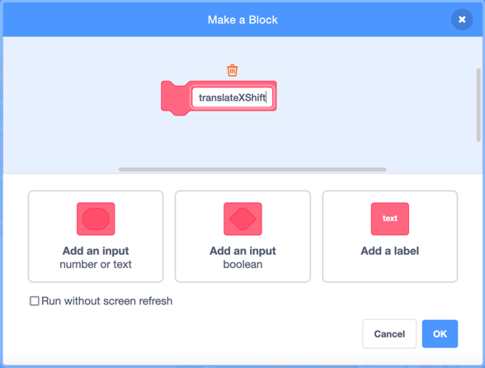
1. Let’s write code for a subprogram
that will translate the 3 vertices
horizontally by shifting the x-coordinate
of each point.
First, make a new block for the
subprogram by selecting My Blocks.
Name it translateXShift.
It will appear in the code editing area.
Drag it to an area where there is room to place blocks below it.
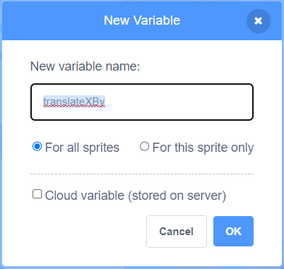
2. You will use set blocks to shift the x-coordinate of each point.
To do this, you will need a variable to hold the value by which
the x-coordinates will shift.
- Select Variables.
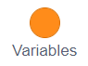
- Select Make a Variable.
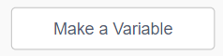
- Name the variable translateXBy.
Using Code to Transform
Triangles (cont’d)

Algebra
Unit 3 Line Master 6b

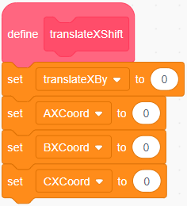
3. Drag four set blocks to beneath the
subprogram called translateXshift
and adjust the pulldown menus as shown
on the right.
Look carefully to make sure you have
selected the x-coordinates of A, B, and C
in the set blocks and not the y-coordinates.
4. You will use operator blocks to add the value by which the
x-coordinates will shift to the original values of the x-coordinates.
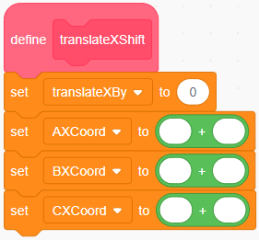
- From Operators, drag an addition
operator to inside each of the set blocks,
as shown on the right.

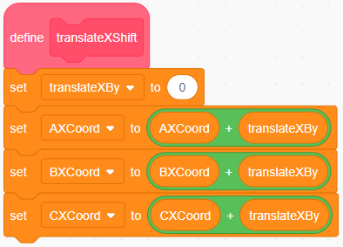
- From Variables, drag the x-coordinate
variables into the first part of each
addition operator.

- Drag the translateXBy variable to the
second part of the addition operator
for each set block.

Note: This can be finicky—take your time. If things don’t snap
into place as you expect, just pull them apart and try again!

Using Code to Transform
Triangles (cont’d)

Algebra
Unit 3 Line Master 6c

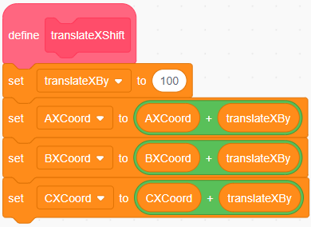
5. Let’s start by shifting the x-coordinates
by 100.
To do this, enter 100 in the set block
for the translateXBy variable, as shown
on the right.
6. Add a comment to let anyone who uses your code know
the range of values they can enter for the translateXBy variable.
To do this, right-click on the set translateXBy block, select Add
Comment, and type this statement:
Input a number between -240 and 190.
This will ensure that, based on the original triangle, the value
the person enters will result in a translation that can be displayed
on the stage. This range will need to be adjusted for different
starting triangles.
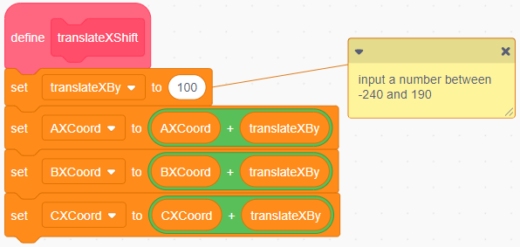
7. Finally, you need to add code to the main program to call
your new subprogram and draw a new triangle with vertices
that have shifted horizontally 100 units from the original vertices.
Adjust the code by adding the 4 blocks
shown here to the end of the main program.

Using Code to Transform
Triangles (cont’d)

Algebra
Unit 3 Line Master 6d

Here’s what these 4 blocks of code do:
- After the main program draws the blue triangle,
the translateXShift subprogram is called up to shift the
x-coordinates of the vertices by 100 units.
- Next, the pen is lifted up to avoid drawing a line while
the sprite moves to the new starting location.
- Then, the pen colour is changed to orange so that the translated triangle can be distinguished from the original triangle.
- Finally, the drawTriangle subprogram is called to action
once again!

8. Click on the green flag to test out the revised application.
Here’s what the stage should look like when the program
has executed. Describe how the triangle has moved.
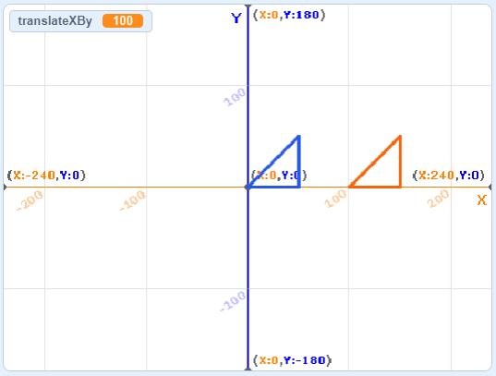

9. Alter the code to translate the original triangle 100 units
to the left instead of the right. What change did you make?

Using Code to Transform
Triangles (cont’d)

Algebra
Unit 3 Line Master 6e

Part 2: Translating the Triangle Vertically
Next, you’ll write code for a subprogram that translates the 3 vertices of the triangle up or down along the y-axis. Here are some tips:
- Start with your version of the application from Step 8
that includes the translateXShift subprogram.
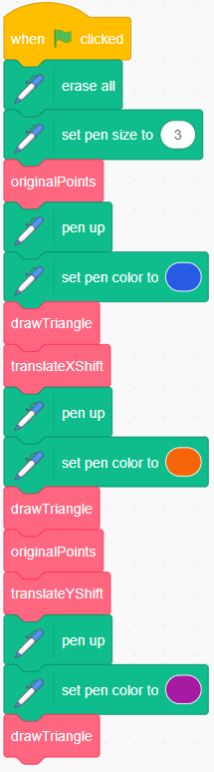
- Write similar code to your translateXShift subprogram,
but call it translateYShift.
- You will need a new variable called translateYBy.
Start with a translation value of 100 units.
- Once you have written your subprogram,
add the following comment to your set block
for the variable translateYBy:
Input a number between -180 and 130.

Here’s what the main program might look like.
Notice that it resets to the original points before
translating vertically by calling the originalPoints
subprogram. This means that the triangle will be
shifted vertically from the original triangle and
not from the triangle that you translated horizontally.
It is possible to translate the second triangle instead.
This is up to you as the programmer!
If you choose to do this, your program will be
missing the block that calls the originalPoints
subprogram. Otherwise, it should look the same
as what is shown here.
If you think your translateYShift subprogram is not working
properly or you get stuck, check with your teacher for a solution.
Using Code to Transform
Triangles (cont’d)

Algebra
Unit 3 Line Master 6f

Additional Challenges
- Write code for a subprogram that reflects the triangle points
in the x-axis. Call the subprogram reflectXAxis.
Hint: You will need a multiply operator.
Why will the subprogram shown here work?
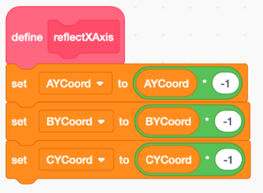
- Write code for a subprogram that reflects the triangle points
in the y-axis. Call the subprogram reflectYAxis.
Think about how it will be similar to reflectXAxis and how
it will be different.
- Prompt the user to enter values for the horizontal translation shift.
Hint: Use the Ask and wait block under Sensing.

