Answers

Algebra
Unit 3 Line Master 6g

Part 1
8. The triangle moved 100 units to the right.
9. To move the triangle 100 units to the left, set translateXBy to −100.
Part 2
Here is what the new translateYShift subprogram should look like: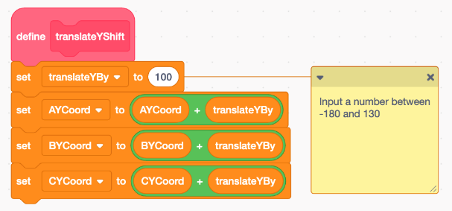
The revised main program is shown on Master 6.
If students shift the original triangle as shown on Master 6,
the stage will look like this:
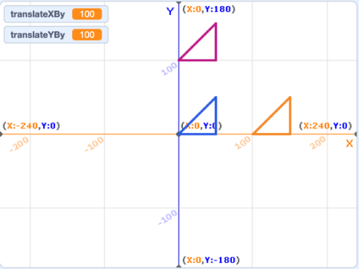
If students choose to shift the second triangle instead and use a pink pen colour for the vertical translation, the stage will look like this:
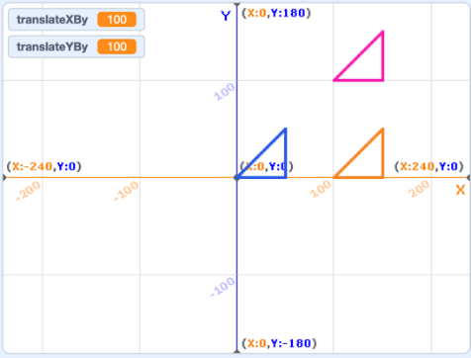
Answers (cont’d)

Algebra
Unit 3 Line Master 6h

Additional Challenges
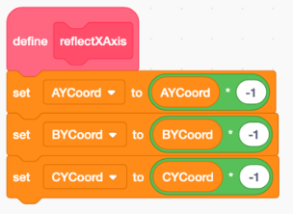
When you reflect in the x-axis, the x-coordinates of the image
stay the same but the y-coordinates have the opposite sign.
As shown on Master 6, the reflectXAxis subprogram should
look like this:

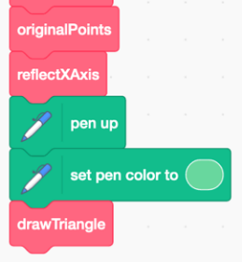
These 5 blocks should be added to the end
of the main program (the pen colour choice
may vary):

The output stage will look something like this:
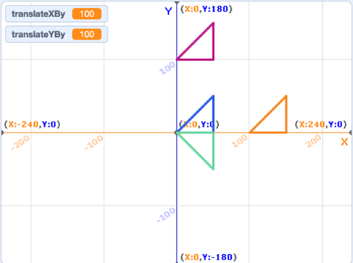
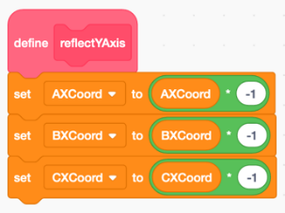
When you reflect in the y-axis, the y-coordinates of
the image stay the same but the x-coordinates have
the opposite sign.
The reflectYAxis subprogram should look like this:

Answers (cont’d)

Algebra
Unit 3 Line Master 6i

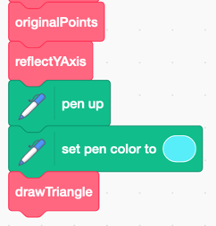
These 5 blocks should be added to the end
of the main program (the pen colour choice
may vary):

The output stage will look something like this:
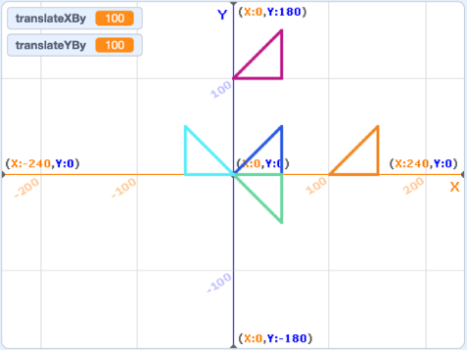
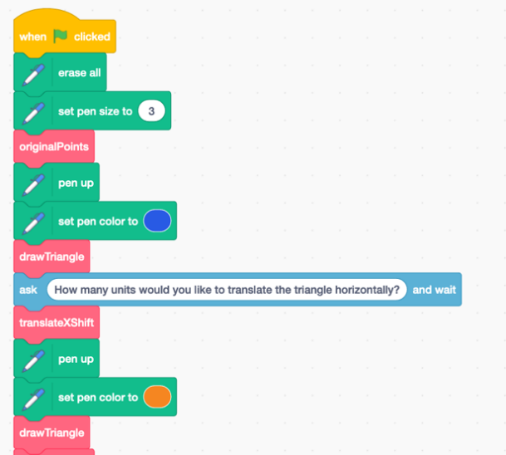
The answers shown for the final challenge assume that the challenges are completed in order, which is not essential.
Students could do this last challenge without doing any of the previous challenges.
The ask and wait sensing block
should be added to the main program
before the first translated triangle
is drawn.

The translateXBy variable should be
set to equal the user’s answer.

Answers (cont’d)

Algebra
Unit 3 Line Master 6j

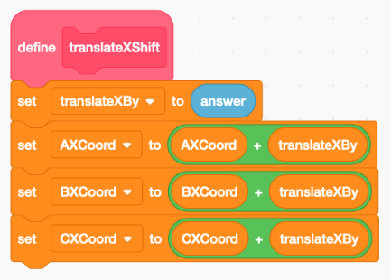

If all challenges are completed with the triangle position being reset each time and the user enters 150 for the horizontal translation,
the output stage should look something like this:
