Altering Code by
Creating Subprograms

Algebra
Unit 3 Line Master 5a

You will be altering the code you used in Master 4 to incorporate subprograms.
A subprogram contains a small set of instructions to complete a task
and is referenced and called to action by the main program.
In Scratch, when we make a new block, we have made a subprogram.
1. Click on the link to open the Scratch application you used
in Master 4.
https://scratch.mit.edu/projects/740509372/editor
2. Let’s start with a block that determines
the x and y coordinates for the points
at the vertices of the triangle.
If you have a Scratch login, save the project in your Scratch account by selecting Remix at the top of the screen.
A login is not required to work with the code, but you will not be able to save your changes without it.
- Select My Blocks
- Select Make a Block
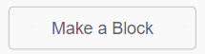
- Name the block originalPoints, since you will eventually
be transforming the points, and click on OK.
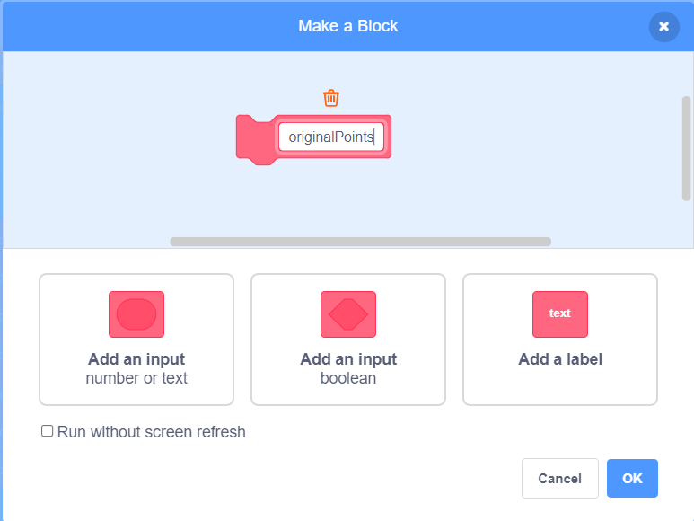
Altering Code by
Creating Subprograms (cont’d)

Algebra
Unit 3 Line Master 5b

- Drag the 6 set blocks from the main code to beneath the originalPoints subprogram as shown below.
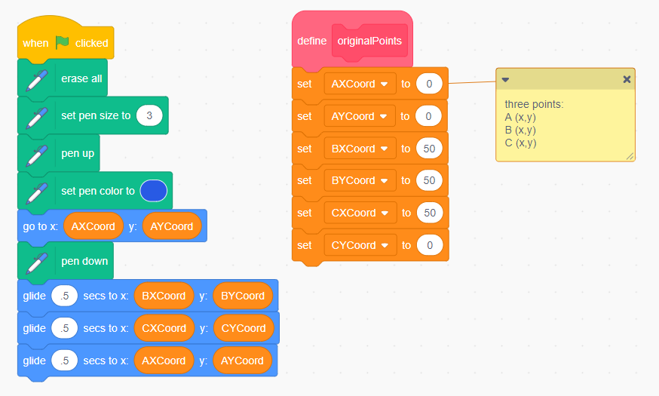
3. You will make one more subprogram, which will contain
the code to draw the triangle.
- Make a second block called drawTriangle and move
the 5 blocks that draw the triangle from the main code
to beneath this new block as shown below.
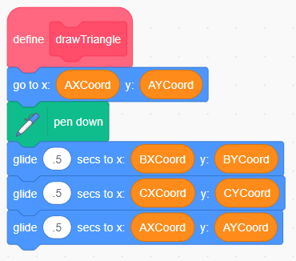

Altering Code by
Creating Subprograms (cont’d)

Algebra
Unit 3 Line Master 5c

4. Now that the subprograms have been created, you need to call
them to action. To do this, you need to go to My Blocks,
and drag the block with the name of each subprogram to be part
of the main program. Make sure you place them in the positions
shown below. This will ensure each subprogram is “called to action”
at the correct time in the program.
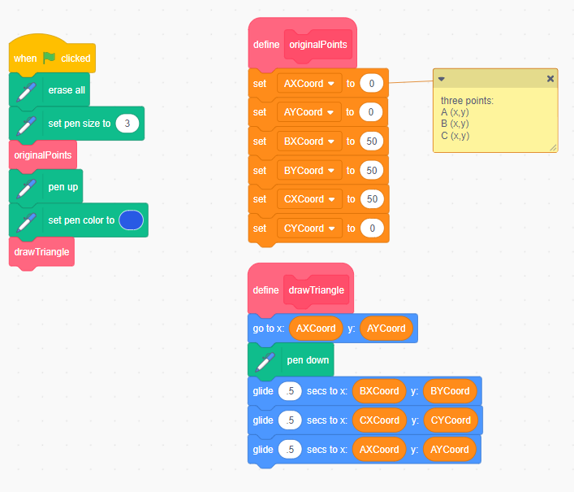
5. Test the program by clicking on the green flag above the stage
to be sure it works as it did before.
6. Take a look at the pseudocode for this application, which is
shown on the next page. There is one “bug” or error in the
pseudocode that will result in output that is not a triangle.
Can you find the error?

Altering Code by
Creating Subprograms (cont’d)

Algebra
Unit 3 Line Master 5d

Pseudocode is an informal way of describing a computer program—
it is somewhere between everyday language and programming code.
Computer programmers, or coders, often use pseudocode when planning
their programs.
originalPoints subprogram
subprogram originalPoints
AXCoord = 0
AYCoord = 0
BXCoord = 50
BYCoord = 50
CXCoord = 50
CYCoord = 0
drawTriangle subprogram
subprogram drawTriangle
go to (AXCoord, AYCoord)
pen down
glide for 0.5 seconds to (BXCoord, AYCoord)
glide for 0.5 seconds to (CXCoord, CYCoord)
glide for 0.5 seconds to (AXCoord, AYCoord)
Main program
erase everything on stage
pen size = 3
run subprogram originalPoints
pen up
pen colour = blue
run subprogram drawTriangle
7. Why do you think it can be helpful to create subprograms
rather than having all the instructions in the main program?
In Master 6, you will create new subprograms that will perform transformations on the vertices of the triangle.

