Using Code to Draw Triangles
on the Cartesian Plane

Algebra
Unit 3 Line Master 4a

Let’s draw a triangle in Scratch by plotting and joining 3 points
on a Cartesian plane.

Go to this application that has been premade in Scratch:
https://scratch.mit.edu/projects/740509372/editor

You will see the following code:
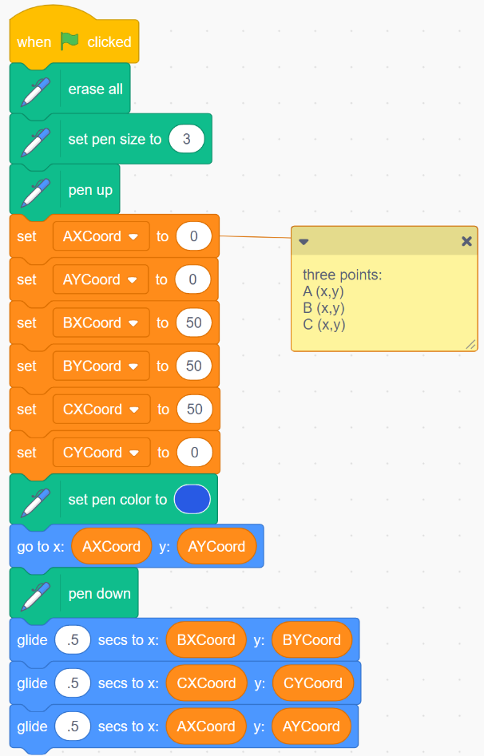
If you have a Scratch login,
save the project in your Scratch
account by selecting Remix
at the top of the screen.
A login is not required to work with
the code, but you will not be able to
save your changes without it.

Using Code to Draw Triangles
on the Cartesian Plane (cont’d)

Algebra
Unit 3 Line Master 4b

1. When you run the program by clicking on the green flag
above the stage, you should see a triangle drawn on the stage:
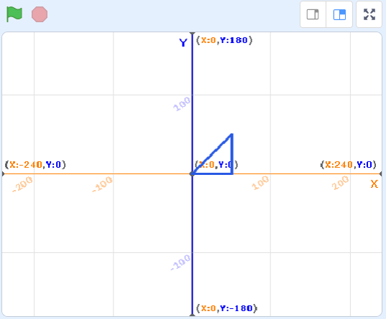

Here are the three points used to draw the triangle and where
in the code you can see the instructions to plot them:
Point A (0,0) | Point B (50,50) | Point C (50,0)
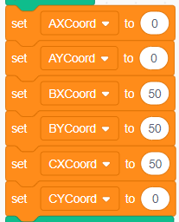

Label the points on the image of the triangle above using
A, B, and C.

Using Code to Draw Triangles
on the Cartesian Plane (cont’d)

Algebra
Unit 3 Line Master 4c

Let’s take a look at the code that draws the triangle.
- First, we set the pen colour to blue.
We also set the drawer sprite to invisible,
which is indicated below the stage.

- Then, we move the drawer sprite to the starting point,
which is (AXCoord, AYCoord). We set these two variables
to (0, 0) earlier in the code.

- Next, we put the pen down so that the sprite will leave a mark
as it glides to each point.

- You can see that we glide the sprite to the B and C points
and then back to the starting point, which is A.

Using Code to Draw Triangles
on the Cartesian Plane (cont’d)

Algebra
Unit 3 Line Master 4d

2. Adjust the points as indicated below and execute the program
to draw each triangle.
Sketch each triangle on the image of the stage provided.
Points | Triangle
a) A(0, 0) B(50, 100) C(100, 0) | 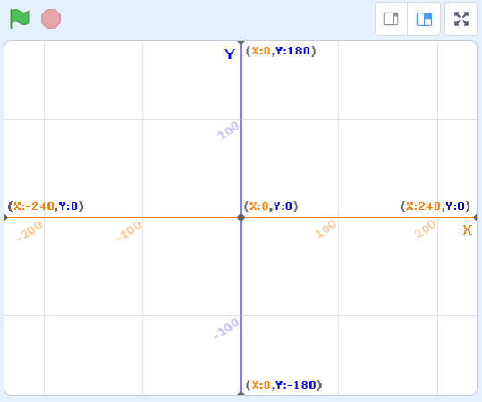
b) A(–100, 100) B(0, 0) C(–100, 0)
c) A(–100, –100) B(–50, –50) C(–100, 0)
Using Code to Draw Triangles
on the Cartesian Plane (cont’d)

Algebra
Unit 3 Line Master 4e

3. Adjust the points two more times to make your own triangles.
Indicate what points you used and sketch the triangles on the
image of the stage.
Points | Triangle
a)
b)

Using Code to Draw Triangles
on the Cartesian Plane (cont’d)

Algebra
Unit 3 Line Master 4f

4. Indicate the points that would be needed to make each
of these triangles.
You can check your answers by entering the points
in the application.
Points | Triangle
a) | 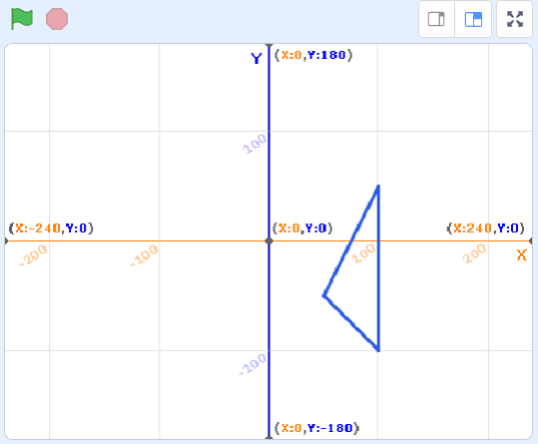
b) | 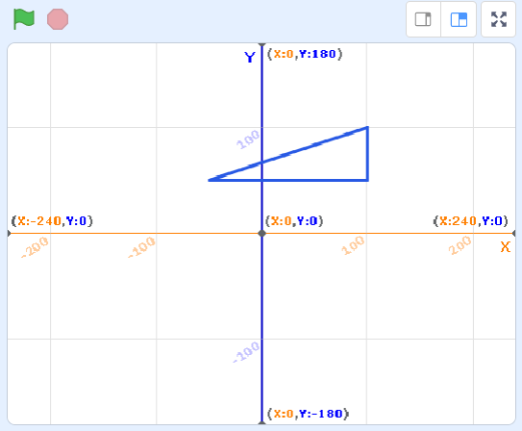

In Master 5, you will adjust the application so that it contains subprograms.

Additional Challenge
Alter the application to draw a rectangle with vertices A(0, 0),
B(100, 0), C(100, 50), and D(0, 50).
Then change the coordinates in your application to draw 2 more different rectangles.

