Answers

Algebra
Unit 3 Line Master 4g

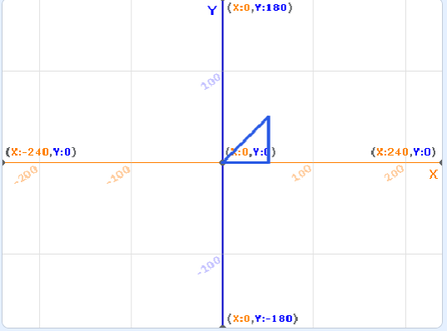
1.

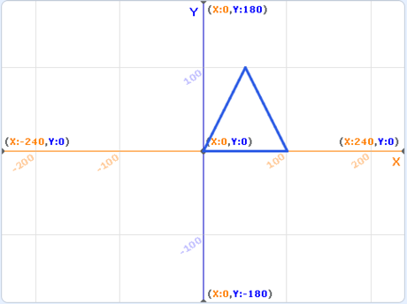
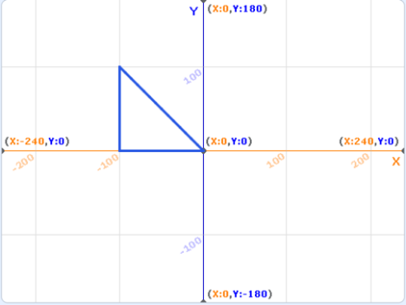
2. a) b)

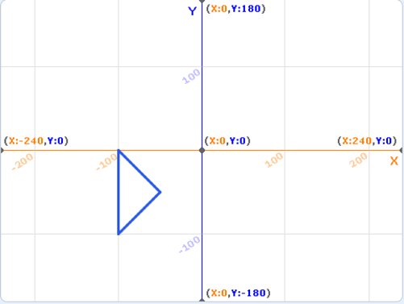
c)

3. Points selected and triangles drawn will vary.
4. Labels assigned to points may vary, sample answers start
from the leftmost point and move clockwise around the triangle.
a) A(50, –50), B(100, 50), C(100, –100)
b) A(–50, 50), B(100, 100), C(100, 50)
Answers (cont’d)

Algebra
Unit 3 Line Master 4h

Additional Challenge
Sample program and stage output for requested rectangle is shown, additional rectangles will vary.
