Using Code to Represent Linear
Patterns in Real-Life Contexts

Algebra
Unit 3 Line Master 3a

Let’s represent patterns in real-life contexts through coding lists
in Scratch.
We’ll begin with the code we used in Line Master 2.

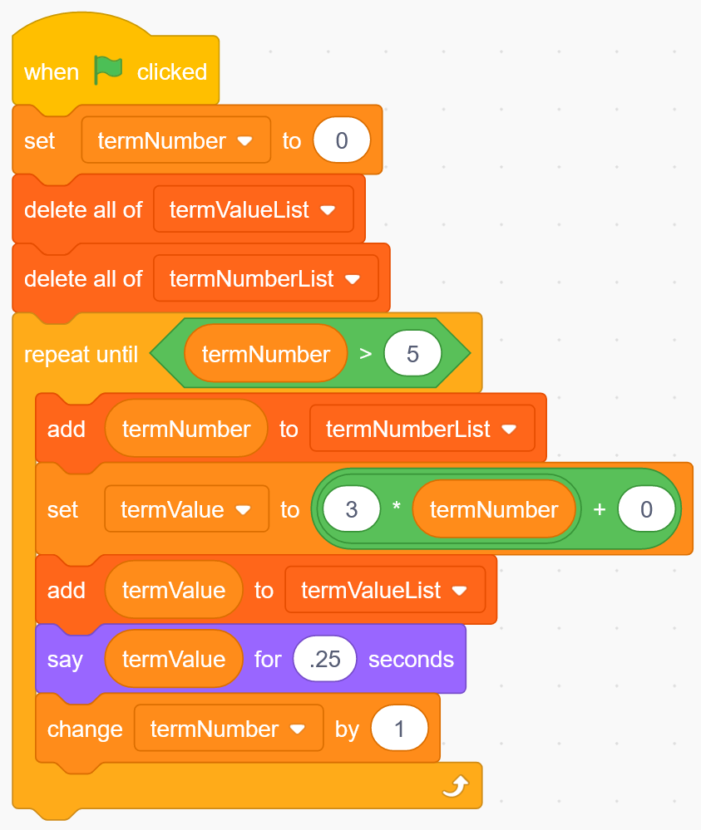
https://scratch.mit.edu/projects/795444171/editor/

If you have a Scratch login,
save the project in your Scratch
account by selecting Remix
at the top of the screen.
A login is not required to work with
the code, but you will not be able to
save your changes without it.

Two real-life scenarios are presented on the following pages.
Represent each of these real-life patterns by altering the code
in this Scratch application.
The real-life scenario in Part 1 includes guided materials.
Work through Part 1 before trying to represent the real-life
pattern using code in Part 2.

Using Code to Represent Linear
Patterns in Real-Life Contexts (cont’d)

Algebra
Unit 3 Line Master 3b

Part 1: Buying Vinyl Records
Ty has decided to purchase used vinyl records from an online store
for their DJ business.
The store charges a flat rate of $25 for shipping and each record costs $5.25.
Ty would like to determine the cost of purchasing 1 through 50 records.

Altering the Code for the Vinyl Records Scenario
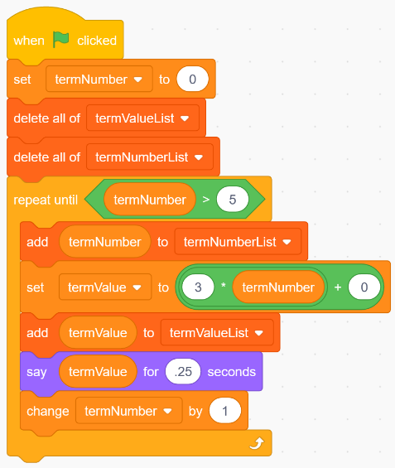
1. Since Ty would like to determine
the cost of purchasing 1 through
50 records, let’s set the starting value
in termNumber to 1 at the beginning
of the code.

2. To ensure the cost of up to and
including 50 records is displayed in
the list, alter the code in the defined
count part of the Repeat to
termNumber > 50.

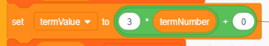
3. The shipping cost is a flat rate, so alter
the initial value in your expression to 25.

The cost per record is $5.25, so alter
the constant rate in your expression to 5.25.

Using Code to Represent Linear
Patterns in Real-Life Contexts (cont’d)

Algebra
Unit 3 Line Master 3c

4. Finally, although this code will display the information Ty
is looking for when it is executed, rename the variables
and lists to have more meaningful names.
- Under Variables, right-click on termNumber and rename this variable numRecords.
- Rename the termValue variable cost.
- Rename the termNumberList to numRecordsList.
- Rename the termValueList to costList.
Your code should look like this:
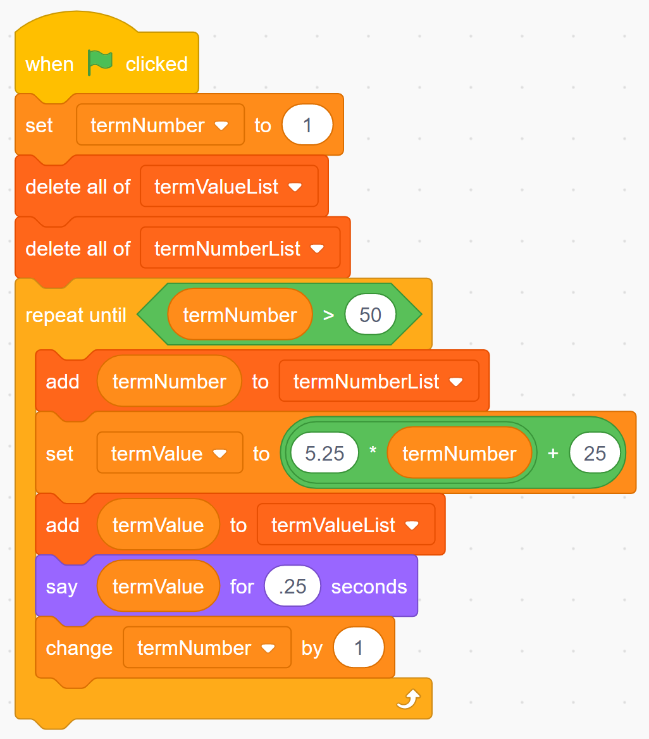

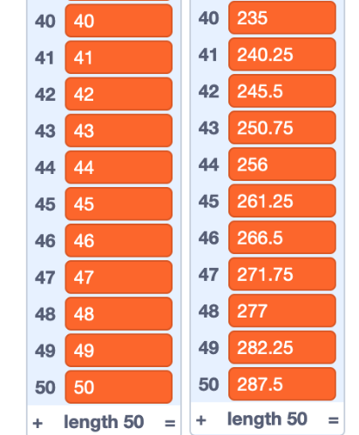
5. Execute the code by clicking on the green flag.
After scrolling down, the numbers at the
bottom of the lists should look like those
on the right.
If they do not, debug your code by checking
if it matches the code above.

Using Code to Represent Linear
Patterns in Real-Life Contexts (cont’d)

Algebra
Unit 3 Line Master 3d

6. a) From your lists, determine the cost to buy 1, 10, 20, 30, 40,
and 50 records.
b) For each number of records in part a, calculate the cost per
record including shipping. Round your answers to the nearest
cent, where necessary.
c) If you were Ty, how many records would you buy to make
the cost of shipping worthwhile? Explain your reasoning.

Part 2: Family Reunion Hall Rental
Grace has a part-time job helping out an event planner.
Grace has been asked to look into renting a hall for a client
who is hosting a family reunion.
Grace is to determine the cost for between 50 and 150 guests
and display this information for every 10 people.
The first venue Grace contacts will charge a flat rate of $750 plus
an additional fee of $5.50 per person. This includes tables, chairs,
and all other supplies, including the use of a kitchen for warming up food,
but not the food itself.

1. Alter the code to represent this real-life scenario.
Use the following variable and list names:
numPeople
numPeopleList
cost
costList

Using Code to Represent Linear
Patterns in Real-Life Contexts (cont’d)

Algebra
Unit 3 Line Master 3e

2. a) What will you use as the starting value for numPeople?
b) How will you alter the defined count part of the code?
c) What values will you use for the initial value and constant rate?
d) How will you change the code so the number of guests
increases by 10 at a time?

3. How much will the hall rental cost for 50 guests?
100 guests? 150 guests?

4. Suppose Grace finds a different hall that charges a flat rate
of $1500 for up to 150 guests and provides the same services.
Which hall would you recommend to the client?
What factors might affect your answer?

