Answers

Algebra
Unit 3 Line Master 3f

Part 1
6. a) and b)
Number of records | 1 | 10 | 20 | 30 | 40 | 50
Cost ($) | 30.25 | 77.50 | 130.00 | 182.50 | 235.00 | 287.50
Cost per record ($) | 30.25 | 7.75 | 6.50 | 6.08 | 5.88 | 5.75
c) Answers will vary.
Sample: I would buy at least 30 records. If you buy only 20
or fewer, you are paying at least 50¢ more for each record
than if you buy 30. After 30, the reduction in the price per record
isn’t as great.

Part 2
2. a) 50
b) I will make the defined count be numPeople > 150
c) I will use 750 as the initial value and 5.50 as the constant
rate (multiplier).
d) I will use 10 in the change numPeople block
The completed code and output should look similar to this:
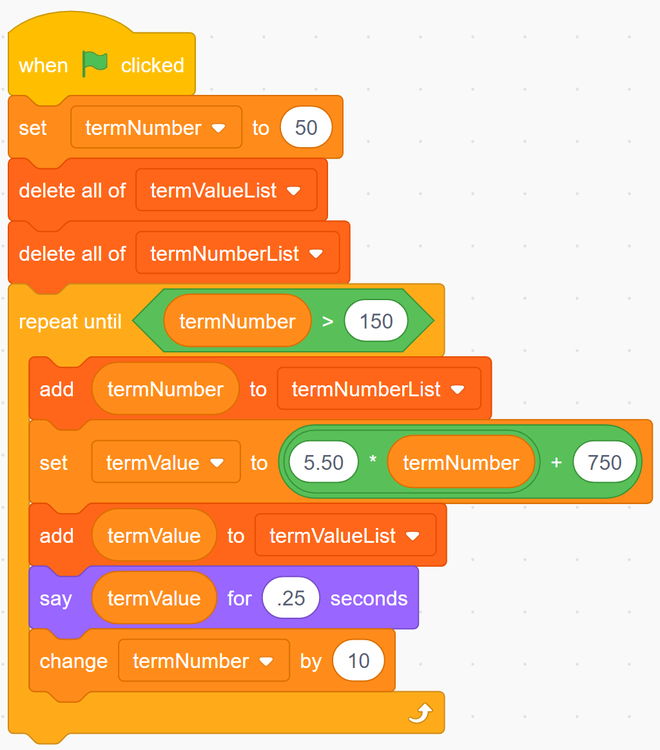 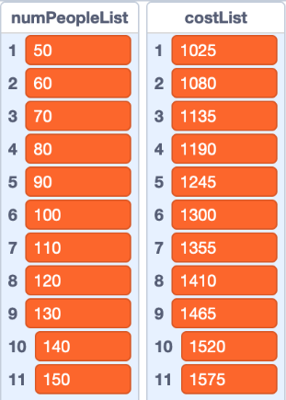
Answers (cont’d)

Algebra
Unit 3 Line Master 3g

3. The cost for 50 guests is $1025, for 100 guests is $1300,
and for 150 guests is $1575.
4. Answers will vary.
Sample: It depends how many guests will be attending the event.
The first hall will cost $1500 to rent when somewhere between
130 and 140 people attend. This is the same cost as the second
option. If any more people attend, the first option costs more.
The recommendation will also depend on the quality of each hall,
any extras they offer, and the convenience of their locations.

