Coding Algebraic Expressions to
Generate Linear Growing Patterns

Algebra
Unit 3 Line Master 2a

You will alter existing code to generate various linear growing patterns that are described using algebraic expressions.
To do this, you will alter the rate of change (multiplier) and
initial values in the code.

Begin with the following application:
https://scratch.mit.edu/projects/795444171/editor/
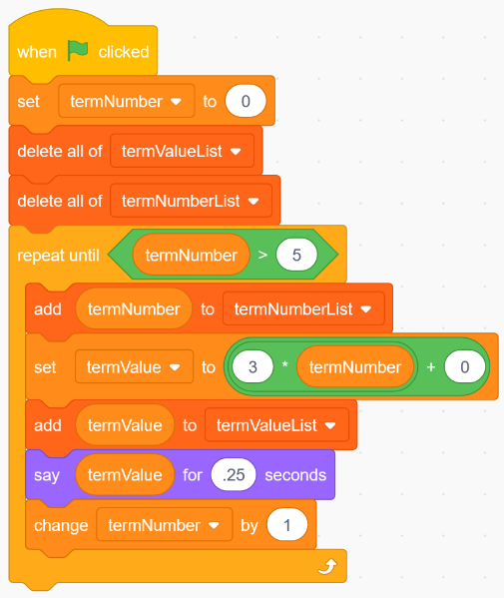
If you have a Scratch login, save the project
in your Scratch account by selecting Remix
at the top of the screen.
A login is not required to work with the code,
but you will not be able to save your changes
without it.

Note: Like the first code you created, this code uses both variables and lists.
In this code, termNumber and termValue are variables, while termValueList and termNumberList are lists.
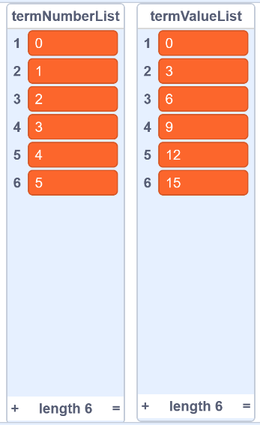
1. Click on the green flag to execute the code.
You will see that two lists are generated and
displayed on the stage—one list called
termNumberList that contains the term
numbers and one list called termValueList
that contains the term values.

Coding Algebraic Expressions to
Generate Linear Growing Patterns (cont’d)

Algebra
Unit 3 Line Master 2b

For term number 0, our term value is 0.
For term number 1, our term value is 3.
For term number 2, our term value is 6.
For term number 3, our term value is 9, and so on.

- What operation do we perform on the term number to get
the term value?

Did you answer “multiply by 3?” That’s correct!
If you aren’t certain how we got this answer, look at the
relationship between the two sets of data:

By what do you have to multiply 1 to get 3?
By what do you have to multiply 2 to get 6?
By what do you have to multiply 3 to get 9?

2. Let’s take a closer look at the algebraic expression that is
used to generate the term values in the code:
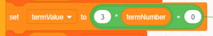
The termValue variable is set to: 3 * termNumber + 0
In coding, an “*” indicates multiplication, so this can be thought
of as 3x + 0, where x is the termNumber.
a) In the code, alter the expression to the following:
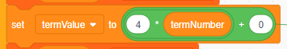
Before executing the code, predict what will be output
in the two lists.
b) Click on the green flag to execute the code.
Was your prediction correct?
Coding Algebraic Expressions to
Generate Linear Growing Patterns (cont’d)

Algebra
Unit 3 Line Master 2c

3. Alter the expression in the code to generate each list of numbers.
For each set of values, write down the expression you use
to generate the term values. The first expression has been
included for you.
a) 5 * termNumber + 0  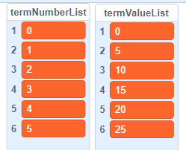 | b) _____________  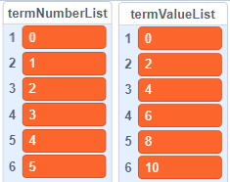 | c) ______________  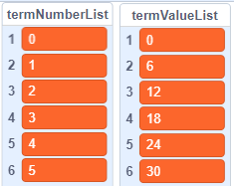

4. Now, let’s alter the expression in the code to use an initial value
of 2, so, that at termNumber 0, the termValue will start at 2.
The new expression is: 3 * termNumber + 2
a) Alter the Scratch code now to reflect this change:
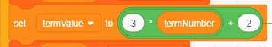

Before executing the code, predict what will be outputted
in the lists.
b) Click on the green flag to execute the code.
Was your prediction correct?

Coding Algebraic Expressions to
Generate Linear Growing Patterns (cont’d)

Algebra
Unit 3 Line Master 2d

5. Alter the expression in the code to generate the lists of numbers
below. For each set of values, write down the expression you
use to generate the term numbers on the blank line.

Hint: The initial value is the value of term 0 and is listed as termNumber 0. The constant rate, or multiplier, is the amount by which the values in the termValueList are changing.
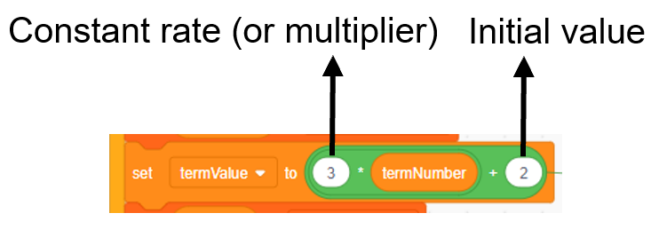

a) _____________  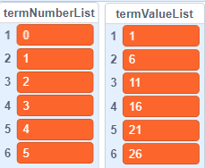 | b) _____________  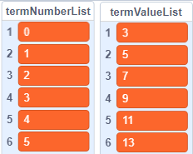 | c) ______________  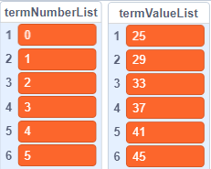
6. Change the expression back to: 3 * termNumber + 2
Now, you’ll alter the code so that you output the term numbers
and values all the way to term number 10.

To do this, change the defined count in the repeat to
termNumber > 10. This will ensure the term values will be
output up to and including term number 10.
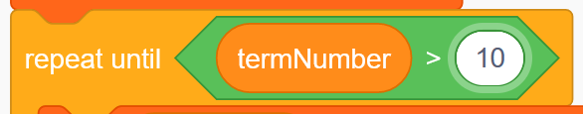
defined count: In coding, the number
of times instructions are repeated,
based on a predefined value or until
a condition has been met.
Coding Algebraic Expressions to
Generate Linear Growing Patterns (cont’d)

Algebra
Unit 3 Line Master 2e

7. Alter the expression and the defined count in the code to generate
the following lists of numbers. For each set of values, write down
the expression you use to generate the term values on the blank
line. Write the number you use for the defined count as well.
a) _____________  defined count:  _____  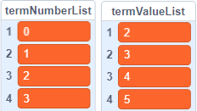 | b) _____________  defined count:  _____  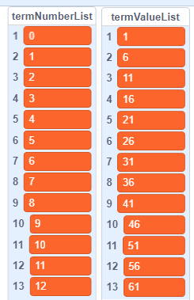 | c) ______________  defined count:  _____  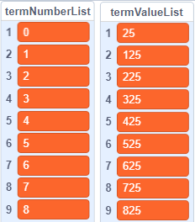
8. Finally, let’s alter the code so that the termNumber variable
increases by an amount other than 1. That is, we will alter the
change termNumber by 1 block.

Let’s start with our original expression, 3 * termNumber + 2,
but output up to term number 100, increasing our termNumber
by 10 each time. The altered code and output are shown
on the next page.

Coding Algebraic Expressions to
Generate Linear Growing Patterns (cont’d)

Algebra
Unit 3 Line Master 2f

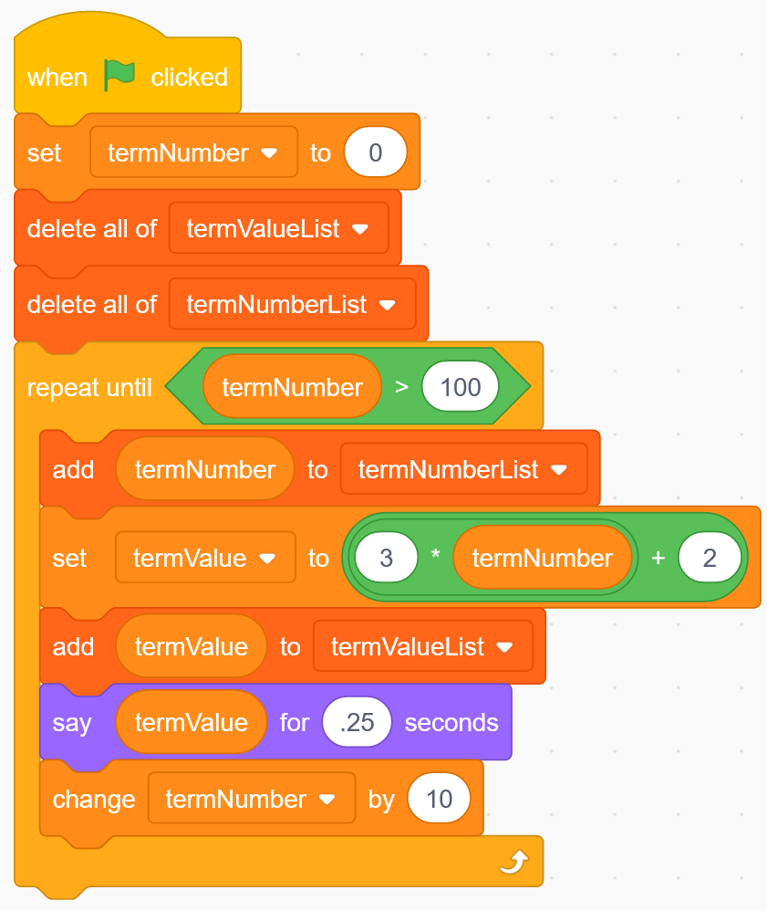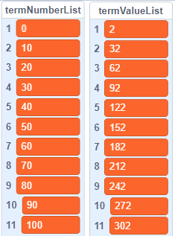
Change this number to 100.
Change this number from 1 to 10.

9. Alter the code to output the following lists of numbers.
For each set of values, write down the expression you use
to generate the term values on the blank line.
What expression did you use in the repeat until block?
By what did you increase the termNumber variable each time?
a) _____________  defined count: _____  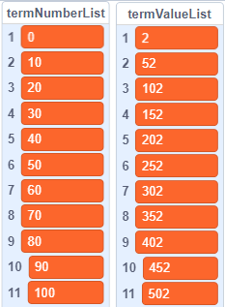 | b) _____________  defined count: _____  