Altering the Code to Perform
Many Tosses

Algebra
Unit 3 Line Master 12a

Coding enables us to simulate activities that would take a long time in real life. For example, if you wanted to toss a real coin 1000 times, it could take more than an hour and it would be challenging to keep track of the results!
Let’s alter the code that you created in Masters 10 and 11 to include repeats and to calculate experimental probability.
You will also use Turbo Mode in Scratch to speed up the calculations.

Open your code from Master 11, or go to this link for the completed application:

https://scratch.mit.edu/projects/806733522/editor/

Part 1: Tossing the Coin Many Times
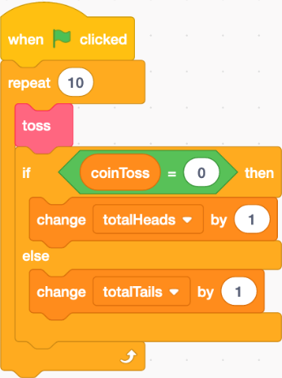
Add a repeat block to simulate tossing a coin many times.
You will be able to adjust the code to simulate 100 tosses,
1000 tosses, or any number of tosses that you choose!
1. Under Control, select a repeat block.
Drag and drop it so it appears around
the code below the when green flag
clicked block, as shown here.

2. Click on the green flag and watch as
10 tosses are automated. This means that,
rather than having to click on the flag 10 times
to simulate 10 coin tosses, you click once and the repeat
does the rest! Click on the space bar to reset the variables.
Alter the number of repeats from 10 to 100.
How many heads are tossed? How many tails?
Altering the Code to Perform
Many Tosses (cont’d)

Algebra
Unit 3 Line Master 12b

3. If you change the repeat value to a larger number such as 1000,
you’ll have to wait a while to see the results.
In Scratch, you can use Turbo Mode.
It will execute the code super fast when you click on the green flag.
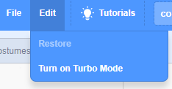
To turn on Turbo Mode, click Edit and then
select Turn on Turbo Mode. You can later turn
Turbo Mode off in the same way.
You will know that you are in Turbo Mode,
when it says Turbo Mode next to the green flag
above the stage.
Set the repeat to 1000.
Click the space bar to reset the variables, then click the green flag
and watch how quickly your results appear!
How many heads were tossed? How many tails?

4. Reset the variables and adjust the repeat value to 10 000.
Execute the program.
a) How many tosses were heads? How many were tails?
b) What was the experimental probability of tossing heads?

c) The theoretical probability of tossing heads is $\frac{1}{2}$, or 0.5
How do you think the experimental probability of tossing heads
will compare to the theoretical probability as you do more
and more coin tosses?
d) Reset the variables and adjust the repeat value to 100 000
or an even larger number of your choice.
Was your prediction in part c correct?

Altering the Code to Perform
Many Tosses (cont’d)

Algebra
Unit 3 Line Master 12c

Part 2: Calculting the Experimental Probability of Tossing Heads

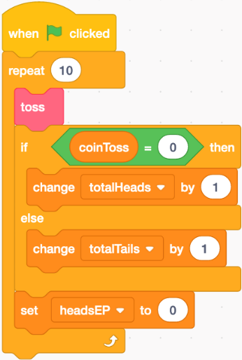
1. Add a block to calculate the experimental
probability of tossing heads. To begin,
you need to make a new variable.
Under Variables, select Make a Variable
and name it headsEP.
2. Under Variables, select the set block and
place it inside the bottom of the repeat block
but below the if-then-else block.
Ensure the headsEP variable is selected
from the pulldown menu.
For now, set your repeat back to 10.

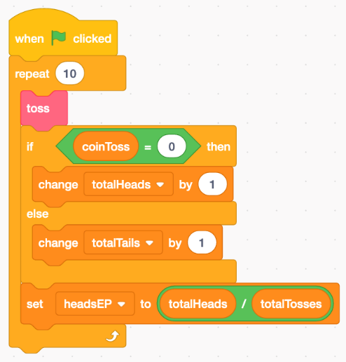
3. a) From under Operators, select
the division operator () and
place it inside the set block.
b) To determine the experimental
probability of tossing heads, you need
to divide the totalHeads variable by
the totalTosses variable.
From under Variables, drag the
totalHeads variable into the first oval
of the division operator and the totalTosses
variable into the second oval.

Altering the Code to Perform
Many Tosses (cont’d)

Algebra
Unit 3 Line Master 12d

4. Add a set block to the reset subprogram for headsEP and ensure
it is set to 0. Your program should look similar to this:
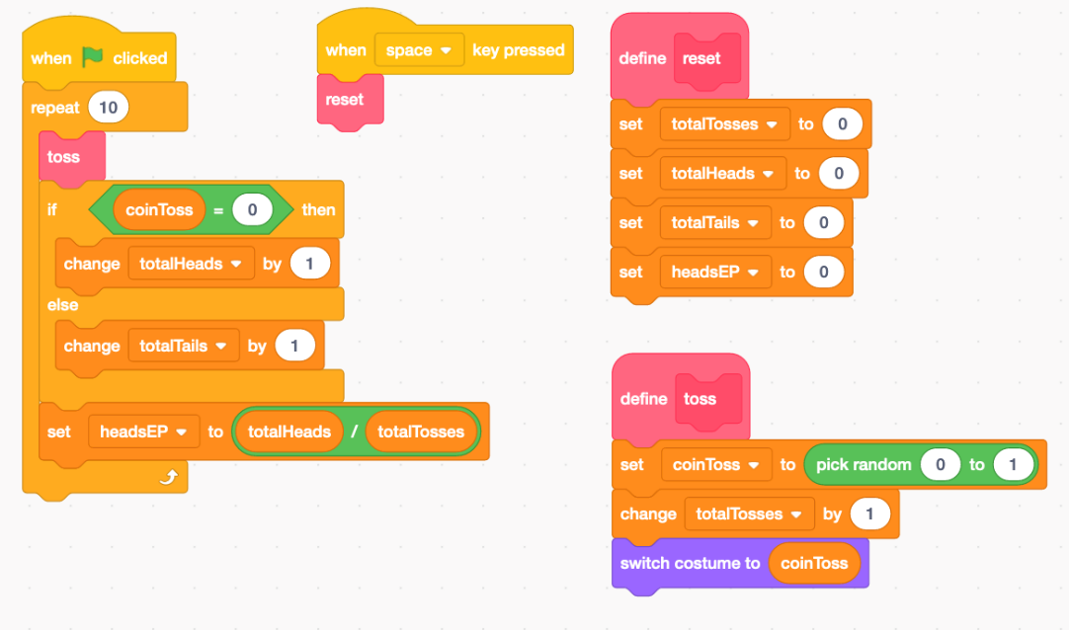

5. a) Click the space bar to ensure the variables are reset.
Execute the code with the repeat set to 10.
You will see the experimental probability for heads displayed
on the stage along with the values of the other variables.
Is the experimental probability calculated correctly?
If not, check for errors in your code.
If it is, move on to part b.
b) Reset the variables again.
While in Turbo Mode, adjust the repeat to 1 000 000 and click
on the green flag. What is the experimental probability of
tossing heads for your 1 000 000 tosses?
Is this what you would expect?
Additional Challenge
Add a block to your code to calculate and display the experimental probability of tossing tails.

