Using Subprograms to Organize
Your Coin Toss Code

Algebra
Unit 3 Line Master 11a

Adjust the Coin Toss application to make the code more organized
by breaking it down into smaller sections.
To do this, you will create subprograms.
A subprogram contains a small set of instructions to complete a task and is referenced and called to action by the main program.
In Scratch, when we make a new block, we have made a subprogram.
Start with the code you wrote by following the guided materials
in Master 10. If you do not have your code saved, you can begin
with this link:

https://scratch.mit.edu/projects/806111487/editor/

You will create two subprograms: one for resetting the variables and one for tossing the coin. The conditional statement part of the code will remain as part of the main part of the program.

Part 1: Creating a Reset Subprogram

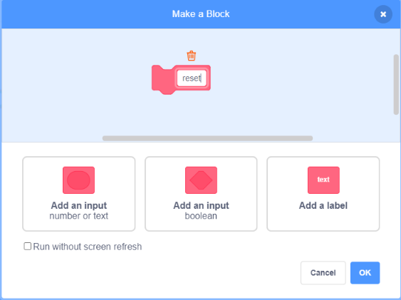
1. To create a subprogram in
Scratch, you need to make your
own block. Under My Blocks,
select Make a Block. Name the
block reset.
Using Subprograms to Organize
Your Coin Toss Code (cont’d)

Algebra
Unit 3 Line Master 11b

2. A new block appears in the code editing area that says define
reset. There is also a new block under My Blocks called reset.
Move your code that resets the variables, which was below the
when space key pressed block, to below the define reset block.
From under My Blocks, select the reset block and drag it to
below the when space key pressed block.
The code is shown below.
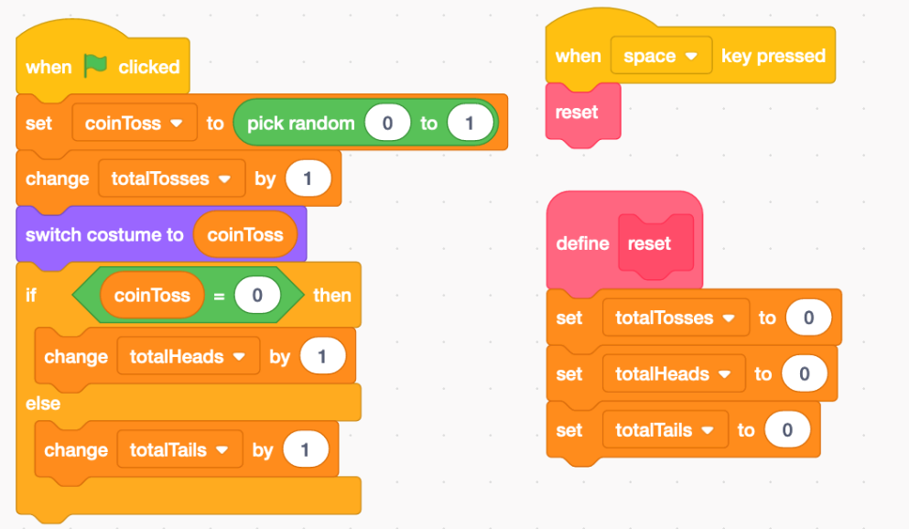

The application should work as before, but now you have reorganized the code to contain one subprogram.

Part 2. Creating a Toss Subprogram

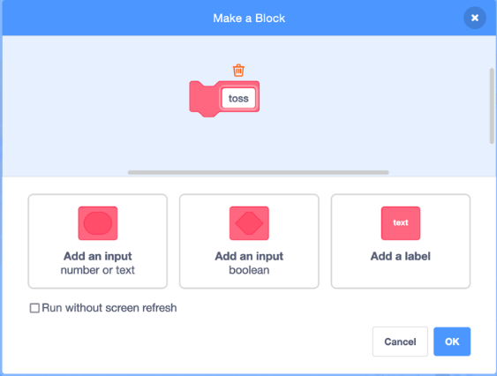
1. The second subprogram you will
create will be to toss the coin.
Under My Blocks, select Make a
Block. Name the block toss.

Using Subprograms to Organize
Your Coin Toss Code (cont’d)

Algebra
Unit 3 Line Master 11c

2. Drag the 3 blocks of code associated with the actual coin
toss to below the define toss block as shown below.
Drag the new toss block below the when green flag
clicked block.
The code is displayed on the below.
Tip: You might find it helpful to pull apart the code, and temporarily place it elsewhere in the code editing window before snapping it
back together.

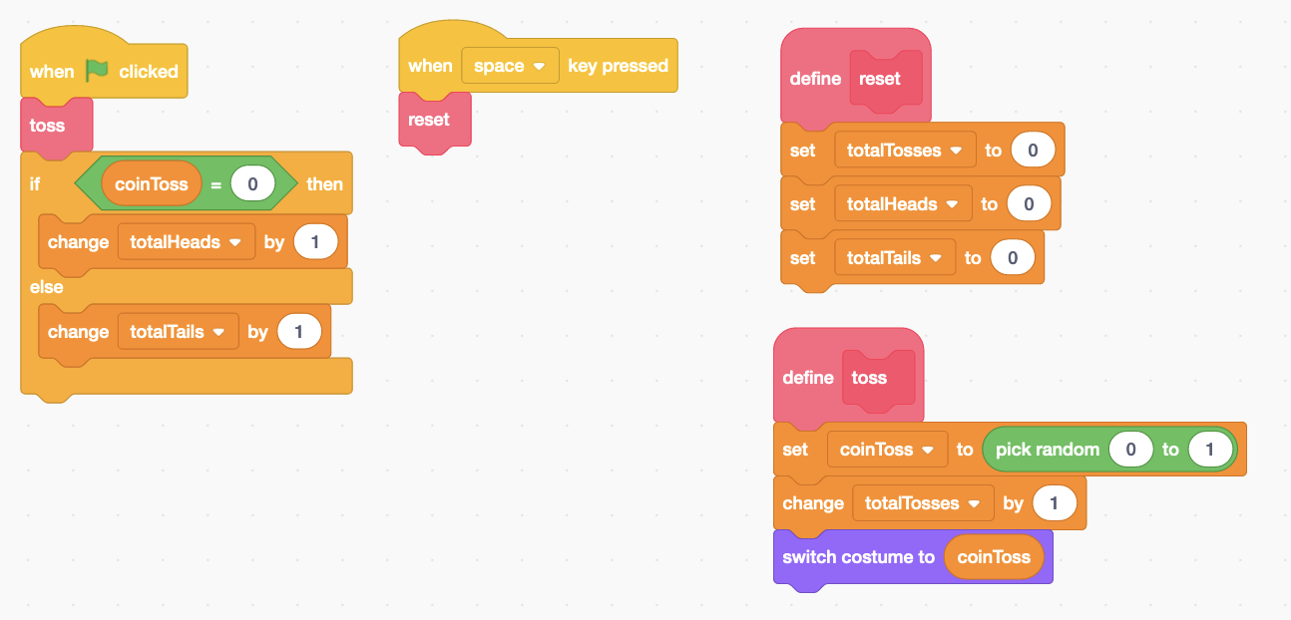
The application should work the same as before, but now the
code is broken down and organized into smaller parts,
called subprograms!

3. Try out the application to ensure that it still works.
You can do this by clicking on the green flag above the stage
many times. What happens to the number of heads?
The number of tails?
If the results aren’t what you expect, look through your code
for any errors.

