Writing Code to Simulate
a Coin Toss

Algebra
Unit 3 Line Master 10a

Let’s explore probability through coding by creating a coin toss simulator application in Scratch.
Start with an existing Scratch application that has a coin sprite with two costumes ready to go: one for heads and one for tails. Click on this link.
https://scratch.mit.edu/projects/692982103/editor
If you have a Scratch login, save the project in your Scratch account by selecting Remix at the top of the screen. A login is not required to work with the code, but you will not be able to save your changes without it.

- You can see this application already has a coin sprite. If you select the Costumes tab (the middle tab on the top left), you will see that the costume that has “H” for heads has 0 for its name and the other costume has a “T” for tails and has 1
for its name.
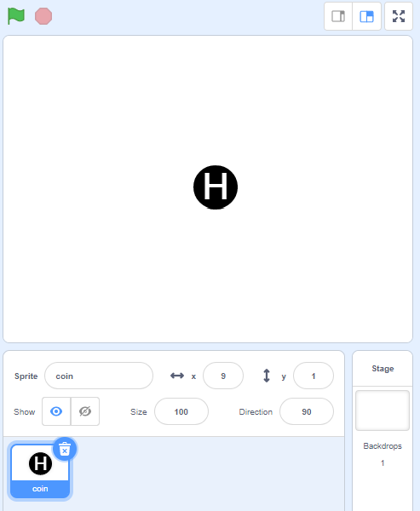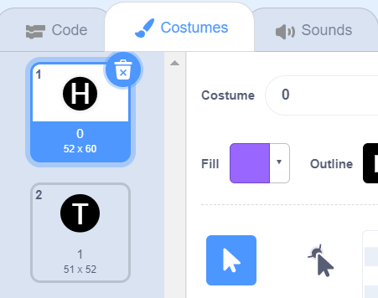
Return to the code, by clicking on the Code tab.
Writing Code to Simulate
a Coin Toss (cont’d)

Algebra
Unit 3 Line Master 10b

2. Start writing the code for the coin toss.
Under Events, select the when green flag clicked block
and drag it to the code editing area as shown.
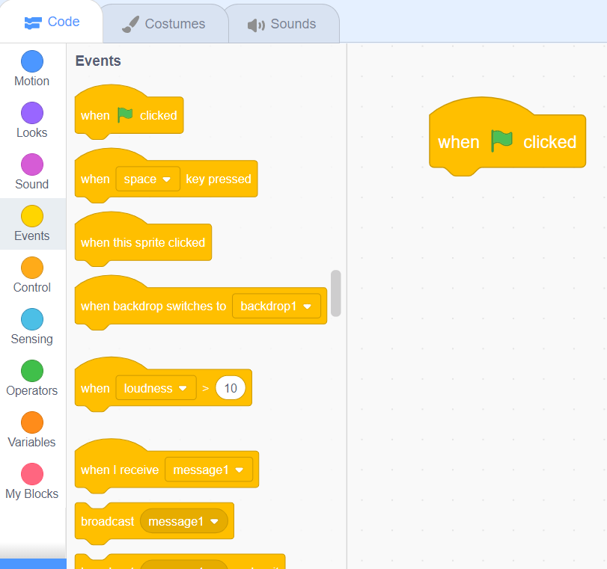
3. Create a variable to hold a random number between 0 and 1.
Later in the code, if the random number is 0, you will display
the coin in its heads costume and if the random number is 1,
you will display the coin in its tails costume.
To make a variable, under Variables, select Make a Variable.
Name the variable coinToss and select OK.
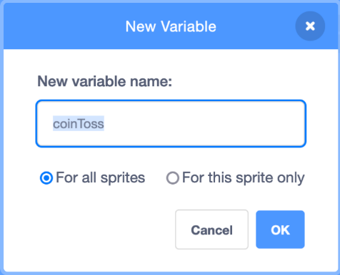

Writing Code to Simulate
a Coin Toss (cont’d)

Algebra
Unit 3 Line Master 10c

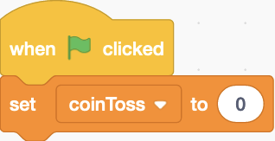
4. Under Variables, select the set block and
ensure coinToss is selected from the
pulldown menu. Place it underneath the
when green flag clicked block.

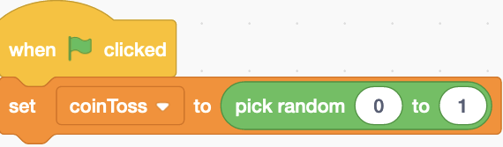
5. Set the coinToss variable to a
random number between 0 and 1.
To do this, go to Operators and
drag the pick random block into
the set coinToss block as shown.
Change the number range to 0 to 1.

6. Now, switch the coin costume to display the H coin costume
if the random number picked is 0, and T if the random number
picked is 1. Under Looks, select the switch costume to block
and drag it beneath the set block.
Because the costumes have already been labelled as 0 and 1
in the Costumes tab, you just need to use the coinToss variable
block from under Variables and place it into the switch costume to
block, since the coinToss variable will either be set to 0 or 1.
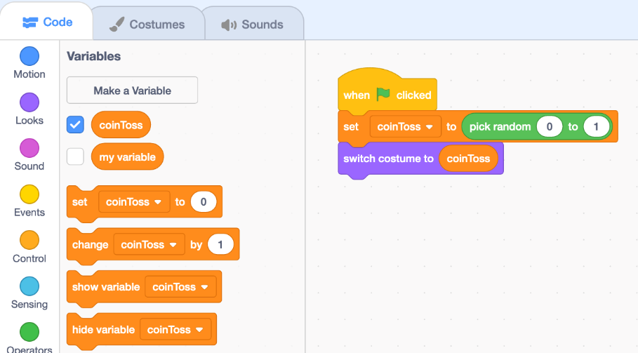
Writing Code to Simulate
a Coin Toss (cont’d)

Algebra
Unit 3 Line Master 10d

7. You need a way to keep track of whether heads or tails
is tossed. To do this, you need two additional variables.
Under Variables, select Make a Variable and name
it totalHeads. Make a second variable called totalTails.
conditional statement: A type of coding instruction used to compare values and make decisions. A conditional statement tells a program to execute an action only if a certain condition is true or false. It is often represented as an if-then or if-then-else statement.

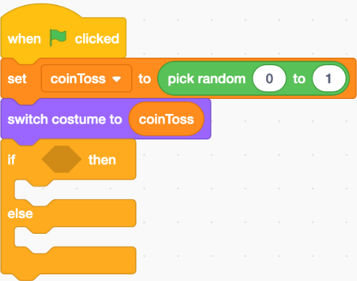
You will use a conditional statement to determine if you need to increase the totalHeads variable by 1 because heads is tossed,
or to increase the totalTails variable by 1 because tails is tossed. Follow Steps 8 to 11 to code the statement.

8. Under Control, select the
if-then-else block and place it
beneath the switch costume to
block.

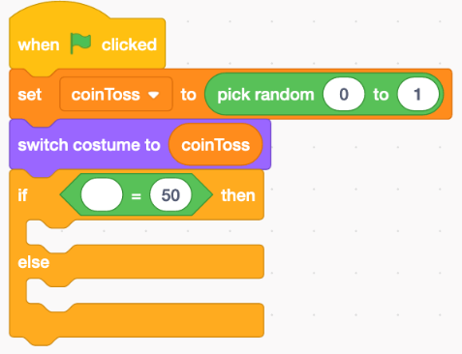
9. Inside the if-then-else block,
you need a comparison operator
to check if something is true or not.
Under Operators, select the equal
(=) comparison operator and place
it inside the first part of the if-then-else
block.
Writing Code to Simulate
a Coin Toss (cont’d)

Algebra
Unit 3 Line Master 10e

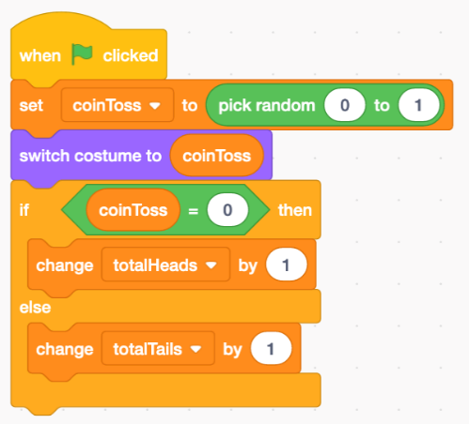
10. You want the program to check if
heads was tossed and, if it was,
increase the totalHeads variable
by 1 as a way of keeping track of the
total number of heads tossed.

Under Variables, select the coinToss
block and place it inside the equals (=) operator.
Change the second part of the equals (=) operator to 0,
rather than 50.

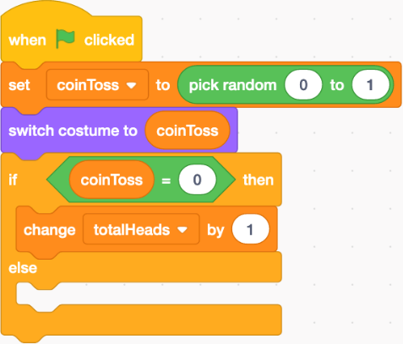
Next, select a change block from
variables and place it below the first
portion of the if-then-else block.
Ensure the totalHeads variable is
selected from the pulldown menu and
that the number 1 is displayed in the
change block so that each time a head
is tossed, the totalHeads variable will
increase by 1.

11. If heads is not tossed, that means tails must have been tossed.
Place a change block inside the else portion of the conditional.
Ensure the totalTails variable is selected in the pulldown menu
and that the number 1 is displayed in the change block so that
each time tails is tossed, the totalTails variable will increase by 1.

Writing Code to Simulate
a Coin Toss (cont’d)

Algebra
Unit 3 Line Master 10f

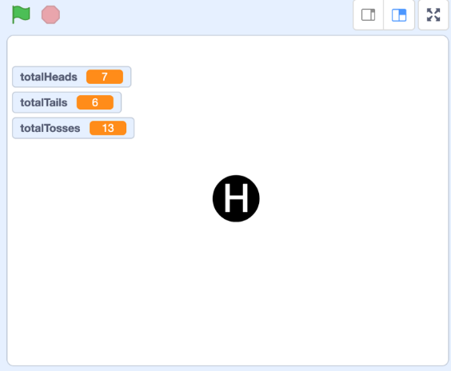
12. Click on the green flag above the stage to execute the code.
Do this many times. The values of three variables are displayed
on the stage. The coin should switch to an H or a T depending
on the random number that is picked. Each time an H appears,
the totalHeads variable increases by 1. Each time a T appears,
the totalTails variable increases by 1.
If these things don’t happen, check your code to make sure
it matches what is shown in the images at each step.
Your stage should look similar to
this but with different numbers
of heads and tails.

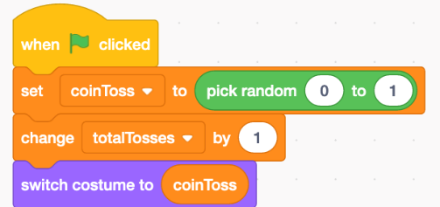
13. Add a variable to keep track of the
total number of tosses. Under Variables,
select Make a Variable and call it
totalTosses. Each time the green flag
is clicked, you’d like the totalTosses
variable to increase by 1. Insert a change block below first set
block in the code and ensure the totalTosses variable is
selected from the pulldown menu. To insert a block, drag it to
where you want it to appear and let go.
The first 4 blocks in your code should look like what is
shown above.
Writing Code to Simulate
a Coin Toss (cont’d)

Algebra
Unit 3 Line Master 10g

14. Finally, add code to reset all of the variables to 0 when the
user presses the spacebar. Under Events, select when
space key pressed, and place it in the code editing window.
Under Variables, select three set blocks and place them
beneath the when space key pressed block.
Select totalTosses from the pulldown menu for the first one,
totalHeads for the second one, and totalTails for the third one.
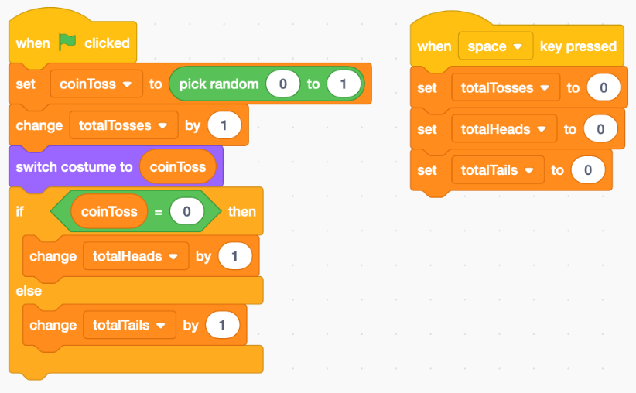
15. Before you run your program again, make sure only certain
variables are displayed on the stage.
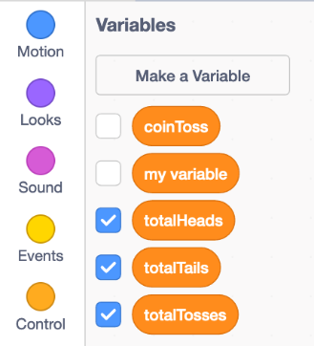
Under Variables, deselect the checkbox for coinToss.
Only the three variables with the checkboxes selected
will be displayed.

Writing Code to Simulate
a Coin Toss (cont’d)

Algebra
Unit 3 Line Master 10h

16. Execute the code several times and then press the space bar.
Did the variable values reset back to 0?
If not, look carefully through the code to make sure you have
everything correct and haven’t missed a step.
We call this process “debugging”.
theoretical probability: when all outcomes are equally likely, the number of favourable outcomes for an event divided by the total number of outcomes

experimental probability: the number of favourable outcomes in an experiment divided by the total number of trials

17. When we toss a fair coin many times, theoretical probability
tells us that we can expect to get half heads and half tails.
a) Reset the variables. Then click on the green flag 10 times.
How many of the 10 tosses are heads? How many are tails?
How close is this experimental result to what theoretical
probability would lead you to expect?
b) Combine your results with 4 other pairs. How many of the
50 tosses are heads? How many are tails?
c) Suppose you could toss a fair coin 10 000 times.
What would theoretical probability lead you to expect
might happen? What do you think might happen?

