Using a Repeat Block to Generate
Simple Number Patterns

Algebra
Unit 3 Line Master 1a

Let’s write code in Scratch that uses a repeat block to generate simple growing and shrinking patterns.

In Part 1, you’ll write code for the basic Scratch application.
In Part 2, you’ll alter the code you’ve just written to generate a variety of growing and shrinking patterns.
Part 1: Writing the basic code for a number pattern
The first number pattern you generate with your program will be:
0, 5, 10, 15, 20, 25
- What is the pattern rule for this set of numbers?

Pseudocode is an informal way of describing a computer program
—it is somewhere between everyday language and programming code. Computer programmers, or coders, often use pseudocode when planning their programs.

The pseudocode for the application looks like this:

clear mypattern[]
number = 0
repeat 6 times
output number
add number to mypattern[]
change number by 5
end repeat

In this code, anything that might have been stored in the list
is deleted.
The starting value of our number variable is set to 0.
In the repeat, number is output, saved in a list called mypattern,
and then changed by 5.
Using a Repeat Block to Generate
Simple Number Patterns (cont’d)

Algebra
Unit 3 Line Master 1b

Since this is repeated 6 times, you will see 6 numbers in your pattern.
Let’s write this code in Scratch. The completed code is shown below, so if you have experience with Scratch you may proceed to recreate it now and skip to Part B. Otherwise, follow the guided materials below.
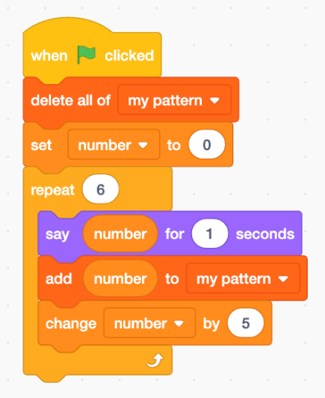
Note: This code uses both a variable
and a list. Variables can hold one value
at a time, whereas a list can hold many
values in an organized manner.
In this code, number is a variable and
mypattern is a list.

Guided Materials*

*Skip to Part 2 if you have already written the Scratch code
based on the image above.

Go to https://scratch.mit.edu/
and select Create to begin.

1. From Events, drag the when green flag is clicked block
to the code editing area.
Using a Repeat Block to Generate
Simple Number Patterns (cont’d)

Algebra
Unit 3 Line Master 1c

2. Create a list called mypattern. To do this, from Variables,
click on Make a List. Enter the name mypattern and click OK.
To make sure the list starts out empty each time you run the code,
add the delete all of mypattern block to your code.
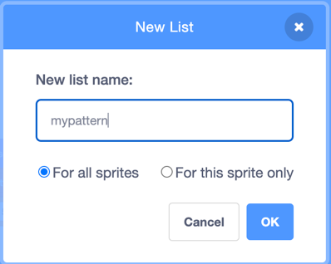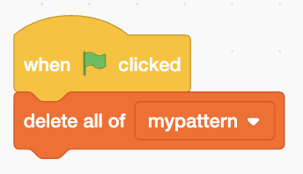
3. Create a variable called number. To do this, from Variables,
select Make a Variable and call it number.
Add the set number to 0 block to your code.
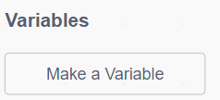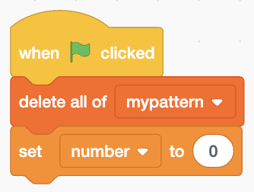
4. From Control, add the repeat block to your code and change
the repeat value to 6.
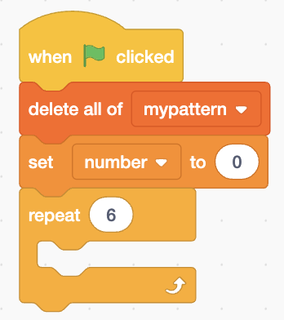

Using a Repeat Block to Generate
Simple Number Patterns (cont’d)

Algebra
Unit 3 Line Master 1d

For Steps 5 to 7, you will be adding blocks inside the repeat block.

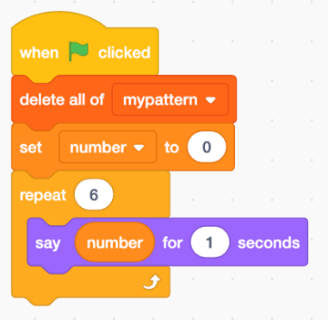
5. From Looks, add the say hello for 2 seconds
block to your code. Change the value from
2 to 1 seconds.
From Variables, drag the number block
to inside of the say block to replace Hello!.

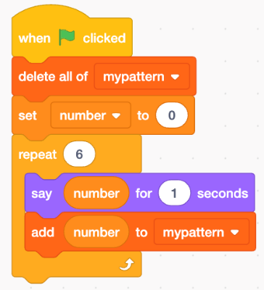
6. From Variables, add the add thing
to mypattern block to your code.
Drag the number block to inside
of the add block to replace thing.

7. Finally, from Variables, add the change number by 1 block
to the code, and adjust the value to 5.
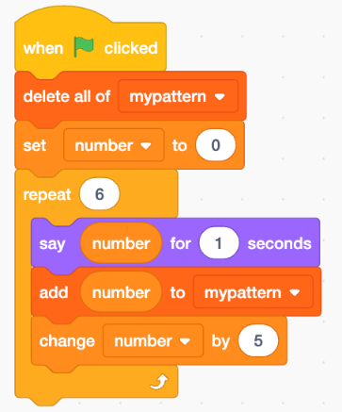
If you have a Scratch login,
save the project in your Scratch
account by selecting Save now
from the File menu.
A login is not required to work with
the code, but you will not be able to
save your application without it.

Using a Repeat Block to Generate
Simple Number Patterns (cont’d)

Algebra
Unit 3 Line Master 1e

8. Click on the green flag above the stage to execute the code.

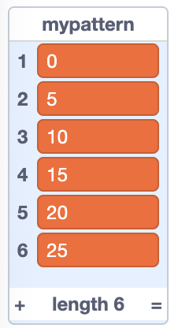
The sprite should output the following numbers,
one at a time, in the speech bubble:
0, 5, 10, 15, 20, 25.
After each number appears in the bubble,
it should be added to the mypattern list.

If the application is not working as expected,
look through the code carefully and debug
by checking whether each part of the code
matches the blocks shown in Steps 1 to 7.

Part 2: Altering the code to generate other growing
and shrinking patterns

- Alter the code to generate a pattern of numbers that increases
by 3 each time. Output 10 numbers in the pattern, beginning at 0.
The numbers output should be: 0, 3, 6, 9, 12, 15, 18, 21, 24, 27.

Here’s the pseudocode to generate this new pattern of numbers:
clear mypattern[]
number = 0
repeat 10 times
output number
add number to mypattern[]
change number by 3
end repeat

Using a Repeat Block to Generate
Simple Number Patterns (cont’d)

Algebra
Unit 3 Line Master 1f

The Scratch code will look like this:
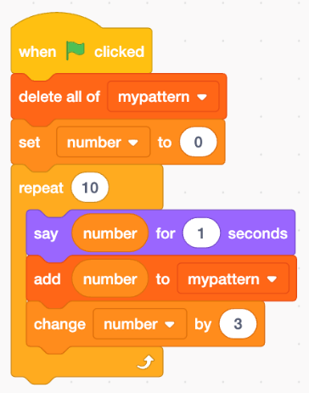

2. Alter this pattern slightly to begin at 9, rather than 0.
The numbers generated should be:
9, 12, 15, 18, 21, 24, 27, 30, 33, 36.
3. Alter the code to generate each pattern of numbers.
What is different about the patterns in parts d) and e)
compared to the patterns in parts a), b), and c)?
a) 0, 4, 8
b) 10, 12, 14, 16, 18, 20, 22
c) 100, 200, 300, 400, 500
d) 100, 90, 80, 70, 60, 50, 40, 30, 20, 10, 0
e) 0, –6, –12, –18

If you get stuck, check with a classmate and/or your teacher for tips.

Additional Challenge
Generate your own patterns and challenge your classmates
to write the corresponding code.

